Large trees as a key factor for bird diversity in spruce-dominated production forests: implications for conservation management

Dominik Kebrle^{a,b}, Petr Zasadilª, Jan Hošek^{b}, Vojtěch Barták^{c}, Karel Šťastnýª
ªCzech University of Life Sciences Prague, Faculty of Environmental Sciences, Department of Ecology, Kamýcká 1176, CZ-165 00 Prague, Czech Republic
^{b}Ecological Services, Tichá 784/4, 268 01 Hořovice, Czech Republic
^{c}Czech University of Life Sciences Prague, Faculty of Environmental Sciences, Department of Spatial Sciences, Kamýcká 129, CZ-165 21 Prague, Czech Republic

Corresponding author.
E-mail address: kebrle@fzp.czu.cz (Dominik Kebrle)
Phone number: +420 739 021 864

Keywords: Beech, Integrative forest management, Old trees, Retention forestry, Veteran trees

Abstract
Large trees (also termed veteran trees or habitat trees) are keystone structures for biodiversity worldwide. Retention forestry aims to keep large trees in production stands to support biodiversity. Nevertheless, there is insufficient information about the effect of large trees on biodiversity and how many large trees should be left in different types of stands, including spruce-dominated production forest. We aimed to investigate the influence of large trees on birds (included generalist and specialist species) in spruce-dominated production forest throughout the Czech Republic while taking into consideration effects of stand age, tree species composition, and distance to a clearing. At 20 study sites (each 600 ha), all trees with diameter at breast height (DBH) ≥ 70 cm were exhaustively searched. We then localized sampling plots representing a gradient of large tree numbers from zero to maximum on each plot. Birds were sampled using point count method in breeding seasons 2018 and 2019. Bird assemblages were analysed using generalized linear mixed models with Poisson error distribution. The total number of birds, number of generalist species, and number of specialist species increased significantly with the number of broadleaved trees ≥70 cm DBH. Furthermore, tree species diversity positively affected generalist species and negatively influenced specialist species. Our results suggest that 5 broadleaved trees ≥70 cm DBH/ha greatly improve bird diversity in spruce-dominated production forests and forest management should be adapted to reach ≥5 native, large, broadleaved trees to improve structural diversity of spruce-dominated production forests.

Introduction
More than half of the forest area in the European Union is covered by forest having production as its primary function (European Commission, 2011). Many native forests in Europe have been transformed into even-aged production forests of such commercially attractive conifers as Norway spruce (Picea abies), which in a large proportion of these places is outside of its original range (FOREST EUROPE, 2020; Klimo et al., 2000). The transformation of native (usually broadleaved) forests to spruce-dominated production forests has often caused the biodiversity of these forests to be very low (Felton et al., 2010; Sweeney et al., 2010). Conversely, unmanaged forest reserves are always the remaining island of the native (mostly broadleaved) forests with high ecological potential in comparison to production forests (Felton et al., 2016; Horák et al., 2019; Lešo et al., 2020). Additionally, about three-quarters of forests in Europe are even-aged, are beyond the regeneration phase, but have not yet reached the mature phase. (FOREST EUROPE, 2020) These are usually forests 20–80 years old (FOREST EUROPE, 2011). Nevertheless, advancing forest age generally increases biodiversity (Moning and Müller, 2008, 2009). In particular, greater forest age increases the abundance of canopy and cavity-nesting bird species (Hobson and Bayne, 2000). For example, the critical forest age threshold for a satisfactory diversity of lichens, molluscs, and birds in European beech (Fagus sylvatica L.)-dominated forests ranges from 100 to 170 years in sub-montane forests and from 160 to 220 years in montane forests (Moning and Müller, 2009). On the other hand, production forestry aims to shorten the rotation length – in beech stands, for example, to less than 120 years (Bütler et al., 2013). Individual old forest structures, such as large, old trees, which are commonly found in non-intervention stands (Nilsson et al., 2003), rarely occur in production forests. These old-growth trees are keystone structures for biodiversity in landscapes worldwide (Lindenmayer, 2017; Prevedello et al., 2018).
Large, old trees (also known as veteran trees or habitat trees) may bear diverse defects (termed tree-related microhabitats, or TreMs), such as canopy deadwood, trunk cavities, cracks, or bark pockets (Bütler et al., 2013; Kolařík et al., 2013; Paillet et al., 2018). The numbers of these TreMs rise with increasing diameter at breast height (DBH) (Larrieu et al., 2014) and the incidence of TreMs increases dramatically on trees with DBH > 70 cm (Larrieu et al., 2012). Many bird species are dependent on TreMs during their life cycles as sources of food, shelter, or breeding habitat (Regnery et al., 2013). For example, Lesser Spotted Woodpecker (Dryobates minor) prefers stands with high occurrence of dead branches (Charman et al., 2012). Furthermore, there is evidence, that woodpeckers prefer trees with larger diameters for excavating breeding cavities (Hebda et al., 2017), and strong excavators, such as Black Woodpecker (Dryocopus martius), excavate cavities preferably in trees with signs of wood decay (Puverel et al., 2019). Abandoned woodpecker cavities can then provide nesting opportunity for secondary cavity nesters (Pakkala et al., 2018). Therefore, large trees play an important role for forest bird diversity, and especially in production forests, where quantities of deadwood are low. The density of large trees with DBH ≥70 cm in managed forest is typically less than 2 trees/ha (Bütler et al., 2011; Bütler and Lachat, 2009). Even such a low number of old trees can be of great importance for some species, however. For example, the Great Spotted Woodpecker (Dendrocopos major) and Black Woodpecker (D. martius) need only a few suitable nesting trees within their territory in order to survive (Vandekerkhove et al., 2013). In modern managed forests, however, logging still systematically eliminates these ‘defective’ trees with low economic value (Bütler et al., 2013). This can negatively affect many forest species, including birds (Horák, 2017; Koch Widerberg et al., 2018; Lindenmayer et al., 2014). An even more vulnerable species group, however, could be habitat specialists linked to these old-growth structures (Birčák and Reif, 2015). Supporting this observation is evidence of different population trends within Europe between habitat-specialized birds species and habitat generalists (Gregory et al., 2007). Generalist species inhabit a wide niche range and are able to use diverse habitat resources. Conversely, specialist species inhabit narrow niche ranges and utilize limited habitat resources. Given that, generalist species are more likely to be tolerant of variable environment conditions than are specialist species. Specialist species, meanwhile, are more likely to be susceptible to extinction (Devictor et al., 2008; Richmond et al., 2005). Accordingly, the population trends among forest specialists are declining in Europe (Gregory et al., 2007).
There nevertheless is evidence of a contrasting increasing trend at national level, specifically in the Czech Republic (CR). Additionally, forest specialists in the CR are positively correlated with an increase in forest coverage (Reif et al., 2007), which has been confirmed also elsewhere (Ram et al., 2017; Reif et al., 2007; Santamaría-Rivero et al., 2016). Similarly, some forest specialist birds increase their densities from forest edges to interior habitats (Terraube et al., 2016) and substantially habitat-specialized bird species can be negatively affected by landscape fragmentation and disturbances (Devictor et al., 2008). For certain bird species, however, including generalists, such diverse factors as forest clearings, canopy openness, forest complexity, size of forest fragment, topography, or even low-traffic forest roads may positively affect bird diversity in these structurally poor forests (Hofmeister et al., 2017; Lešo et al., 2019; Šálek et al., 2010; Żmihorski, 2016). In other words, generalist bird species can be positively influenced by the edge effect (Batáry et al., 2014; Hofmeister et al., 2017). Conversely, birds associated with the forest interior (forest specialists) prefer homogenous forest interiors and can be negatively affected by forest gaps and edges (Hofmeister et al., 2017). Another important positive factor is increasing proportion of native broadleaved tree species, which, in particular, increases bird diversity in spruce-dominated monocultures (Fuller, 2000; Sweeney et al., 2010; Vélová et al., 2021). For example, an admixture of just one broadleaved tree species into spruce monocultures can lead to increased bird diversity (Felton et al., 2010). Moreover, broadleaves trees in coniferous plantations have a great effect on bird numbers if dispersed, rather than if situated in a few large blocks (Bibby et al., 1989).
Spruce-dominated production forests constitute a large part of forests in central Europe and this, together with ongoing forest management, depletes bird diversity. Although several studies have explored the influence of large trees on diversity of birds or saproxylic beetles in broadleaved or mixed production forests (e.g., Augustynczik et al., 2019; Remm et al., 2006; Winter and Möller, 2008), research is lacking on the influence of individual large trees on bird assemblages in spruce-dominated production forests. Our aim is to investigate the influence of large trees on total bird species richness, number of generalist bird species, and number of specialist bird species in spruce-dominated production forest throughout the Czech Republic. Furthermore, we aim to determine a threshold value for the number of large trees in spruce-dominated production forest that are needed to have a significant effect on bird diversity. Additionally, we want to ascertain the importance of large trees for individual species of birds. The lack of large, old trees in production forest stands could be one of the factors explaining the declining population of habitat-specialized species in Europe. Large, old trees are important elements for forest diversity, and their protection should therefore be a priority. The results of our study can contribute to careful forest management by describing when to leave large, old trees in production forests to support biodiversity. At the same time, the results can bring new insights regarding the different trends of forest bird generalist and specialist species within Europe (Gregory et al., 2007). The protection of large, old trees in production forests is also beginning to be applied thanks to retention forestry, which is an element of integrated forest management (Mölder et al., 2020). In many areas, unfortunately, large, old trees are still threatened by forest management, and therefore it remains necessary to draw attention to their importance for supporting biodiversity.

Materials and methods

Study area and design
The study was conducted in spruce-dominated production forests in the CR. Forests cover approximately 34% of the CR, with Norway spruce (Picea abies) encompassing about half the total forest area (MZe, 2020). Although the original range of spruce forest was limited to montane areas of the CR, forest management practice often involved replacing original broadleaved stands in lower areas with spruce-dominated forests (Neuhäuslová et al., 1997, 1998, 2001). Furthermore, due to forest management, the proportion of forests older than 120 years is less than 9% in the CR (MZe, 2020). We examined 20 study sites across the country. Each study site is a 600-ha circle (ca 1.4 km radius) of non-fragmented forest area. The selection of study sites was limited by the minimum size of forest (600 ha). Distances between study sites ranged from 6.5 to 432 km (mean 130.5 km). The study sites occupy elevations ranging from 357 to 947 m a.s.l. In addition, we selected the nearest unmanaged forest reserve (distance from study site ranging from 0.6 to 19.1 km, mean 6.7 km) as a control for each study site. On each study site, all live trees with DBH > 70 cm were exhaustively searched and their locations were recorded. This DBH threshold was chosen due to dramatic increase in the number of TreMs occurring above 70 cm DBH (Larrieu et al., 2012). Additionally, 70 cm DBH corresponds to an age of about 160 years for beech (Dobrovolný and Tesař, 2010). Similarly, all live trees ≥70 cm DBH were exhaustively searched within a 1 ha circle of each study area (r = 56.4 m) in selected control forest reserves. Based on the occurrence of trees ≥70 cm DBH, localized sampling plots (circle r = 100 m) were created at each study site within production forests; these represented a gradient of large trees ≥70 cm DBH, with numbers from zero to maximum on each study site (beech or, less often, other broadleaved trees were preferred as microhabitat-rich and native tree species [Larrieu et al., 2012; Larrieu and Cabanettes, 2012]). Additionally, we avoided clearings, forest roads, and forest edge. The minimum distance of sampling plot centres from forest edge, busy roads, or clearings larger than 0.25 ha was 100 m. Due to areas with very low occurrence of trees ≥70 cm DBH, however, the avoidance condition for small forest roads and small clearings below 0.25 ha was limited to the middle ha of the sampling plot (i.e., 50 m around the sampling plot midpoint). The minimum distance between sampling plot midpoints was 200 m. We studied birds in spruce-dominated production forest. Therefore, we used information about tree species composition from forest management plans (to ensure the proportion of spruce). Furthermore, we analysed the canopy cover of broadleaved trees by digitizing aerial photographs to obtain accurate estimates as to proportions of broadleaved trees within sampling plots (r = 100 m). Based on these analyses, we excluded sampling plots where the canopy cover of broadleaved trees exceeds 50% of the sampling plot area (r = 100 m). In total, we selected 180 sampling plots in spruce-dominated production forests and 20 sampling plots (r = 56.4 m) in unmanaged forest reserves. The location of study sites (600 ha), examples of sampling plots (r = 100 m) in production forest, and example of sampling plot in forest reserve (r = 56.4 m) are shown in Fig. 1.
Data from forest management plans show the dominant type of forest vegetation within the selected sampling plots (r = 100 m) located in production forests to be coniferous forests (80%). Norway spruce (P. abies) was the most dominant tree species (total 76%), followed by Scots pine (Pinus sylvestris) and European larch (Larix decidua). Silver fir, (Abies alba) as well as some exotic tree species such as Douglas fir (Pseudotsuga menziesii), grand fir (Abies grandis), and eastern white pine (Pinus strobus) are also represented in very small proportions. Broadleaved forest vegetation occupies 12.9%. The dominant broadleaved tree species is European beech (Fagus sylvatica) (total 7%). Other broadleaved trees present are oaks (Quercus petraea, Quercus robur), alders (Alnus glutinosa, Alnus incana), silver birch (Betula pendula), small-leaved lime (Tilia cordata), sycamore (Acer pseudoplatanus), European ash (Fraxinus excelsior), European hornbeam (Carpinus betulus), rowan (Sorbus aucuparia), aspen (Populus tremula), and field elm (Ulmus minor), with exotic tree species such as horse chestnut (Aesculus hippocastanum) and red oak (Quercus rubra) also represented in very small proportions. Cleared area, forest <20 years of age (both broadleaved and coniferous), and non-forest vegetation (forest roads and other paved areas) occupy in total 6.9% of the study sampling plots. The weighted mean age (weighted by area of forest stand group) of production forest stand groups (excluding forest groups <20 years) within sampling plots is 78.6 (SD 21.1) years. In unmanaged forest reserves, the mean proportion of broadleaved forest cover within 100 m around sampling plots centre is 84%, with beech the dominant tree species in most reserves. The weighted mean age (weighted by area of forest stand group) of forest reserves stand groups is 157 (SD 63.6) years.

Bird survey
Bird surveys at all study sites and forest reserves were carried out during 2019 and 2020 by a point count method (Bibby et al., 2000) from the midpoint of each sampling plot in spruce-dominated production forests and midpoint of each plot in control forest reserves. Each midpoint was surveyed twice in the same year, during April–May for early nesters and May–June for late nesters (Bouvet et al., 2016). Intervals between consecutive visits exceeded two weeks. Surveys were conducted within 4 h of sunrise and were restricted to good weather conditions (Batáry et al., 2014; Bibby et al., 2000). All bird counts were performed by the same person. All individuals heard or seen within 50 m of the midpoint were recorded. Owls and other raptors (<0.3% of the birds recorded) were excluded from our analyses as the point count method is inappropriate for them (Bouvet et al., 2016). Additionally, we excluded Fringilla montifringilla, which is not a nesting species in the CR. In total, 200 midpoints (180 in production forest and 20 in forest reserves) were surveyed, 106 of which were surveyed in 2019 and 94 in 2020.
Bird species were classified into generalist and specialist species (Supplement 1), for which we expected different responses based on habitat specialization. We adopted the attributes regarding bird habitat specialization relevant in the CR as reported by Reif et al. (2010).

Spatial and environmental variables
We used the number of all live trees ≥70 cm DBH [NumLT70DBH] (58% beech, 30% spruce, plus Douglas fir, oaks, larch, or silver fir < 2.8% in total) and number of only broadleaved trees ≥70 cm DBH [NumBroadlLT70DBH] (91% beech, 6% oaks, plus ash, limes, sycamore, or alder (< 1.6% in total) occurring within sampling plots area (r = 100 m) in production forests as environmental variables explaining the effect of large trees in spruce-dominated production forests. Spatial attributes of forest stands were obtained from aerial photographs (scale 1:5000) using a geographic information system (ArcGIS 10.4). For each sampling plot midpoint, we determined the nearest distance to the forest edge or clearing (whichever was closer) [ClearCutDist]. We analysed the type of forest vegetation as follows: (i) broadleaved forest [Broadl_cover], (ii) coniferous forest [Conifer_cover], (iii) young forest <20 years (both broadleaved and coniferous) [Young_cover], all within sampling plot areas (r = 100 m). Furthermore, we calculated Shannon’s index for tree species diversity [H_Trees], defined as follows: $H´=-\sum_{i=1}^{S}{p_{i}\ln{p_{i}}}$, where $p_{i}$ is the proportion of covered area in each stand group within sampling plots in the ith tree species and S is the number of tree species. The maximum value for Shannon’s index occurs when the proportions are equal across all species (Staudhammer and Lemay, 2001). To include forest age as a factor, weighted average age of forest stand groups [AgeWMean] (weighted by area of each group) and standard deviation (SD) of forest group age were calculated [Age_SD]. SD of age represented the heterogeneity of forest stand group age. Age and representation of individual tree species in individual forest stand groups were obtained from forest management plans.

Data analysis and modelling
The maximum number of bird species from both controls recorded at each counting midpoint was used as a response variable. We used generalized linear mixed models (GLMMs, package lme4 in R [Bates et al., 2015]) with Poisson error distribution to evaluate the effect of environmental variables on total bird species richness and species richness of generalist and specialist bird species in spruce-dominated production forests (1 ha plots in forest reserves were not included in this analysis). Study site identification [ID_study_site] was used as a random intercept term to take into account that local communities sampled at individual sampling plots inside a given study site form an inter-connected metacommunity, and thus the corresponding observations are not independent. To check for possible multicollinearity, we computed variance inflection factors (function vif in the R package car, (Fox & Weisberg, 2019) for all predictors and found large values for coniferous and broadleaved forest cover (8.2 resp. 6.3). This was confirmed by high (and expectable) negative correlation between these two variables (r = -0.85). Therefore, we excluded coniferous forest cover from the list of model predictors. After fitting a full model with all predictors, we performed a was selected via backward stepwise model selection, excluding in each step the insignificant predictor with the largest p value in the Wald χ2 test comparing the model with and without the predictor. In the final model, we kept only predictors with p < 0.1. We checked possible overdispersion by Pearson’s χ2 test (R package performance, [Lüdecke et al., 2021]), and we evaluated the model performance by variance-function-based coefficient of determination (Zhang, 2020a) using function rsq from the R package rsq (Zhang, 2020b).
To determine the threshold values of large broadleaved tree density (important for bird diversity), we divided densities of live broadleaved trees ≥70 cm DBH in spruce-dominated production forest into four categories: 0, 0<>1 (mean: 0.58), 1<>3 (mean: 1.89), and 3<>9 (mean: 4.93) trees per ha (number and intervals of tree density were chosen with respect to the number of plots in each category). We then compared the bird species richness of generalist and specialist, as well as total species richness, between these density groups with species richness in forest reserves (R, mean: 22.8; SD: 10.4 broadleaved trees ≥70 cm DBH/ha) using generalized linear mixed models with Poisson error distribution (using IDs of study site and closest forest reserve as random intercept terms) and simultaneous comparison of density categories and adjustment of p-values for multiple testing by means of the function glht, R package multcomp (Hothorn et al., 2008).
Additionally, we used redundancy analysis (RDA) with 5 density categories of broadleaved trees ≥70 cm DBH (0, 0<>1, 1<>3, 3<>9, and R) to indicate specific preferences of species regarding large broadleaved tree densities. Calculations of RDA were performed using the vegan package for R (Oksanen et al., 2019). All analyses were done in R 4.0.3 (R Core Team, 2020). The complete commented code is in Appendix XXX.

Results
In total, we recorded 41 bird species (35 species at 180 points in spruce-dominated production forest and 33 species at 20 points in forest reserves; 23 generalist and 18 specialist species). Fringilla coelebs was observed most frequently, with 179 occurrences in production forest, followed by Periparus ater (165), Erithacus rubecula (159), and Regulus ignicapilla (149). Regarding the occurrence of woodpeckers, Dendrocopos major was observed at 91 points and Dryocopus martius at 3 midpoints. In forest reserves, the species most frequently observed were Fringilla coelebs and Turdus merula (20), followed by Dendrocopos major, Troglodytes troglodytes, and Erithacus rubecula (17). Regarding the occurrence of other woodpeckers, Dendrocopos leucotos was observed once. A few species were recorded only in forest reserves: Ficedula parva, Ficedula albicollis, Muscicapa striata, and Dendrocopos leucotos. Conversely, a few species were recorded only in production forests: Phylloscopus trochilus, Sylvia borin, Poecile palustris, Lophophanes cristatus, and Nucifraga caryocatactes.

Effect of large, old trees and other forest factors
All three final GLMMs (i.e., for total, generalist species and specialist species bird richness) resulting from the backward selection only included the number of broadleaved trees ≥70 cm DBH (NumBroadlLT70DBH) and Shannon’s diversity index of tree species (H_Trees) as predictors (see Table 1 for model coefficients and Appendix XXX for all model outputs). The former predictor had significant positive effect on bird species richness in all three models; the increase in number of broadleaved veteran trees from 0 to 20 led to an increase of the mean number of species – averaged across all random effect levels – from 9.8 to 13.4, from 7.9 to 10.9, and from 4.6 to 6.6 for all, generalist, and specialist species, respectively (Fig. 2). The Shannon’s index was significant for generalist and specialist bird species richness, but insignificant (p = 0.073) for the total bird species richness (Appendix XXX). Whereas mean total resp. generalist species richness increased with Shannon’s index (from 9.8 to 10.8 resp. from 7.2 to 9.1 with the Shannon’s index increasing from 0 to 1), its effect on the specialist bird species was opposite (the mean number of specialist species decreased from 5.9 to 4.4 with the Shannon’s index increasing from 0 to 1; see Table 1 and Fig. 5).

Comparison of production forests and forest reserves
The density of broadleaved trees ≥70 cm DBH within sampling plots (r = 100 m) in production forests ranged from 0 to 8.3 trees/ha. In contrast, the density of broadleaved trees ≥70 cm DBH in forest reserves ranged from 9 to 45 (mean: 22.8; SD: 10.4) per ha. According to the GLMMs and post-hoc test, the total species richness and richness of generalist species is significantly higher in categories 3<>9 (mean: 4.9 trees/ha) and R (mean: 22.8 trees/ha) than in plots in production forests where the large broadleaved trees are absent. The mean total number of species is 3.3 (for category 3<>9) and 2.9 (for category R) higher compared to plots with absence of large trees (Fig 3a). The mean number of generalist species is 3.1 (for category 3<>9.) and 4.0 (for category R) higher compared to plots with absence of large trees (Fig. 3b). Additionally, the difference in total species richness and number of generalist species between category 3<>9 and forest reserves is non-significant (Fig. 3a and 3b). For forest specialists, only non-significant results were detected (Fig. 3c). In comparison to results of total species richness and generalist species, however, the mean number of specialist species in the reserves (R) is lower (about 0.3 species) than the mean number in the category representing absence of large broadleaved trees (0) (Fig. 3c).
Considering all bird species, the RDA plot showeed some cavity-nesting species (e.g., Sturnus vulgaris, Dryocopus martius, Columba oenas) and several shrub-nesting species (e.g., Turdus merula, Sylvia atricapilla, Turdus viscivorus) to be associated with forest reserves (R). Some bark creepers (e.g., Certhia familiaris, Dendrocopos major, Sitta europaea) and some secondary cavity-nesting birds (e.g., Cyanistes caeruleus, Parus major) are associated with sampling plots in category 3<>9 large broadleaved trees per ha. Furthermore, in plots with less than 1 tree per ha (0; 0<>1), there are often associated species nesting in the tree or shrub layer or foraging in the canopy (e.g., Pyrrhula pyrrhula, Periparus ater, Regulus regulus, Regulus ignicapilla, Spinus spinus, Phylloscopus collybita). Results of the RDA analysis are shown in Fig. 4.

Discussion
The main aim of the study was to determine the importance of large, old trees for common forest birds in spruce-dominated production forests. We found a positive effect from the number of large broadleaved living trees (≥70 cm DBH) on the number of generalist and specialist bird species, as well as on total bird species richness. Additionally, the total number of bird species and number of generalist species were even similar between plots in unmanaged forest reserves and production forests having mean 4.9 large broadleaved trees ≥70 cm DBH per ha. Surprisingly, we found very low numbers of specialist species in forest reserves. In particular, creepers were associated with large tree-rich sampling plots (4.9 broadleaved trees ≥70 cm DBH). Of the other characteristics tested, we found a contrasting effect of tree species diversity on specialist (negative) and generalist (positive) species.

Importance of large, old trees for diversity
Large old tress trees are known to be important habitats, especially for insect species (Grove, 2002; Horák, 2017; Koch Widerberg et al., 2018; Pilskog et al., 2020; Sverdrup-Thygeson et al., 2017). The large, old trees seems to provide important habitat mainly for less-mobile organisms, such as lichens, lignicolous fungi, and bryophytes (Hofmeister et al., 2015, 2016). Similarly, there is evidence, that birds also are positively associated with large-diameter trees (Basile et al., 2020; Gutzat and Dormann, 2018; Klein et al., 2020). For example, cavity-nesting birds of temperate and boreal forests have been shown to select for nesting trees on average 13.3 cm thicker than all trees occurring in an area and having mean diameter of 35.6 cm. Additionally, the probability of nest selection was seen to increase as tree diameter increased and trees with diameter ≥ 43 cm had a probability >50% to be selected as a nest tree (Gutzat and Dormann, 2018). The preference for thicker trees by cavity nesters may be due to the fact that the larger trees with harder sills provide more thermally stable cavity environments (Vierling et al., 2018). Considering these findings, it is evident that these large-diameter trees can provide important nesting opportunity for cavity-nesting birds especially in young production stands with trees of small diameter. Trunk diameter in most cases reflects tree age. Stand age is an important factor for the diversity of birds, but also for molluscs or lichens (Moning and Müller, 2009). The weighted mean age of production forest stand groups in our survey point was only 78.6 (SD 21.1) years, however, and therefore probably has no effect on the number of bird species. A further explanation for this lack of effect can be a similar range of ages for forest stands in the monitored study areas and also for stands in their surroundings. On the other hand, the positive effect of old-growth forest structures such as large trees was significant for all bird assemblages. The age of large trees ≥70 cm DBH is about 160 years for beech (Dobrovolný and Tesař, 2010). The recorded age of forest stands reflects the year of planting of the forest stand group and does not consider the age of individual large, old trees. Thus, the recorded age of forest stand groups did not always reflect these old-growth structures in production forests. According to the literature, in order to sustain cavity breeding species, the age of Central European mixed montane forests needs to surpass 200–220 years (Moning and Müller, 2008) and critical age limits for bird diversity in beech stands have been set at between 80 and 100 years for the submontane stage and around 150 to 220 years for the montane stage (Moning and Müller, 2009). Forest management, however, maintains stands mostly up to ca 130 years of age, when wood growth is greatest. In the case of beeches in particular, the maximum for production is 120–140 years due to the formation of red heartwood in still older trees (Knoke, 2003; Moning and Müller, 2009). These facts are reflected in the age of the stands of interest. Stand age therefore plays an important role in forest stands, and forest management should be modified to age the stands. In order to promote biodiversity, a certain part of the stand should also be left completely free of intervention so that the trees can go through their entire life cycle.
The influence of large trees has so far been studied in more detail only in insects. The link between large trees and bird species is less explored. Furthermore, there have been no such studies from spruce-dominated forest. We have now found a positive effect of large trees (broadleaved large trees specifically) on birds in spruce-dominated production forests. Individually occurring large trees in a production forest are thus old-growth attributes from forest reserves that function like lifeboats for a number of taxa and are also important for birds. One explanation for the importance of old trees is the presence of tree-related microhabitats (TreMs) caused by climate, activity of organisms, mechanical injuries, or decay (e.g., canopy deadwood, cavities, cracks, bark pockets) (Bütler et al., 2013; Paillet et al., 2018). Numbers of TreMs rise with increasing DBH (Larrieu et al., 2014), and the incidence of TreMs increases dramatically on trees with DBH > 70 cm (Larrieu et al., 2012). Many species, including birds, are dependent upon TreMs during their life cycles to provide sources of food, shelter, and breeding habitat (Regnery et al., 2013). Consistent with this this understanding, we found that creepers (Certhia familiaris, Dendrocopos major, Sitta europaea) in particular were associated with these large tree-rich plots. For these species, large trees with TreMs can be sources of food and nesting opportunity. Although in the CR hollow-bearing trees (or den trees) in production forest are sometimes searched out and marked to prevent them from being harvested, not solely hollow-bearing trees can be important and should be maintained in otherwise diversity-poor production stands. The importance of large trees can be important over the long term, and especially for nesting. Due to the decomposition of dead trees (Hardenbol et al., 2019), for example, the lifespans of cavities excavated in live trees are longer than are lifespans of cavities in dead trees. Nevertheless, large trees cannot fully replace dead trees, which are irreplaceable for some species groups. Generally speaking, snags (i.e., standing, dead, or dying trees) are particularly important for primary cavity-nesting birds (Remm et al., 2006) and live trees can be especially valuable in stands where the incidence of dead trees is very low (such as spruce-dominated production forest). Moreover, live mature trees are suitable for more bird species than are dead trees (Hannan et al., 2019).

Broadleaved large trees
A number of studies have focused on broadleaved tree species (Koch Widerberg et al., 2018; Pilskog et al., 2020; Sverdrup-Thygeson et al., 2017). Similarly, the number of broadleaved trees with DBH ≥ 70 cm was chosen as a better predictor in our analysis compared to the total number of coniferous and broadleaved trees. It is known that broadleaved trees bear many more TreMs than do conifers (Larrieu et al., 2012; Paillet et al., 2019; Vuidot et al., 2011). As an example, 70% of beech but only 18% of firs bear one or more TreMs (Larrieu and Cabanettes, 2012). Similarly, broadleaves such as ash, beech, chestnut, hornbeam, maple, oak, and poplar have shown higher microhabitat accumulation rates than do conifers like fir, larch, and spruce (Paillet et al., 2019). On the other hand, the number of TreMs increased dramatically above 71.6 cm DBH for beech and similarly above 68.4 cm DBH for fir (Abies alba) (Larrieu et al., 2012). Choosing the same DBH threshold for tree registration should therefore not play a role, as large broadleaved trees may probably be more important for birds than are coniferous large trees, and especially in coniferous-dominated forests. The importance of large broadleaved trees may derive from the very fact that they are broadleaved trees. The positive effect of broadleaved trees on birds in non-native coniferous monocultures has been mentioned by several authors (Felton et al., 2010; Fuller, 2000; Sweeney et al., 2010). In our plots, the proportion of broadleaved trees was limited to 50% in order to maintain a high proportion of conifers. Indeed, there is evidence of greater bird species diversity in spruce–birch polyculture (Betula spp.) than in spruce monocultures (Felton et al., 2010). Furthermore, broadleaved trees in coniferous production forests have stronger effect on the number of birds and species if dispersed rather than if they are in a few large blocks (Bibby et al., 1989). Individual occurrences of large deciduous trees in a spruce monoculture may thus have a better effect on birds than does a continuous stand of deciduous trees. The mixing of broadleaved trees in spruce-dominated forests is in fact a diversification of a niche, which can then be used by a wider range of species. This effect should be further supported, however, by the occurrence of TreMs. The tree species factor and TreMs occurrence can have a synergistic effect on bird species numbers. Perhaps this is why we found a significant effect of large broadleaved trees, whereas our analysis did not find total broadleaved tree cover alone (including younger trees) to be significant. Moreover, broadleaved tree species (especially beech) constituted the dominant component in the original natural stands replaced by spruce-dominated forest in the CR (Neuhäuslová et al., 1997, 1998, 2001). Large broadleaved trees can thus be important for bird diversity, regardless of whether they bear any TreMs. In support of this, we found a positive effect of large broadleaved trees without information about TreMs occurrence. Vuidot et al. (2011) report that the tree characteristics such as DBH that strongly reflect microhabitat occurrence and forest management generally had no effect on microhabitat indices. Hence, information about tree species is very important and, together with DBH, may be used for easily identifying trees with high ecological value for retention in production forests. Admixture of broadleaved tree species in coniferous-dominated monocultures increases bird diversity and can be an important tool in protecting birds while maintaining the productive function of the forest. On the other hand, the negative effect of Shannon’s diversity index for tree species on specialist species suggests that these bird species prefer rather homogeneous stands with a few tree species. The link between specialists and homogeneous coniferous stands can also support an increase in their number with a growing share of forest cover, which was found in the CR between 1982 and 2003 (Reif et al., 2007). Meanwhile, generalist species were positively associated with the Shannon’s diversity index for tree species. For the sake of conserving all bird assemblages, there is probably a need to increase the tree species diversity in forest stands while at the same time, maintaining a certain share of existing spruce-dominated forests.

Critical thresholds for large trees and comparison with forest reserves
Several studies from Switzerland have found density of large trees (trees with DBH > 70 cm) in production forests there to remain less than 0.5 to 2 trees per ha (Bütler et al., 2011; Bütler and Lachat, 2009), whereas in virgin forests of Central Europe and southern Scandinavia this is between 10 and 20 (Nilsson et al. 2003). This corresponds to our findings. The high ecological potential of forest reserves in comparison to non-native forests is known (Horák et al., 2019). In forest reserves the numbers of threatened or near-threatened bird species or cavity-nesting species, such as woodpeckers, are higher, or may occur there even exclusively (Felton et al., 2016; Lešo et al., 2020). Similarly, we found some higher-risk Czech Red-Listed bird species (Chobot and Němec, 2017) exclusively in forest reserves, such as Ficedula parva (Vulnerable), Ficedula albicollis (Near Threatened), and Dendrocopos leucotos (Endangered). Additionally, Columba oenas (Vulnerable) was more numerous in forest reserves than in production forests. On the other hand, D. leucotos was recorded only once and it cannot be said that forest reserves appeared to be more favourable to them. To reduce the negative impacts of forest management, 5 to 10 habitat trees per ha are recommended (Bütler et al., 2013). These recommended numbers (in particular the lower threshold) approximately correspond to our plots with mean 4.9 large broadleaved trees per ha (range 3 to 9 trees per ha), which was the maximum amount found in spruce-dominated production forests within 100 m sampling plots. It is not very clear, however, which of the habitat trees are really important (e.g., with regard to tree species). Additionally, these recommended numbers were not specified for various types of forest stands. Our study shows that for spruce-dominated production forest, about 5 broadleaved trees ≥70 cm DBH per ha can increase the number of bird species to numbers similar to those found in small forest reserves and increase the total species richness by 3.3 species in comparison to forest without occurrence of large broadleaved trees. We would consider this value as the lower threshold of the recommended amount. Therefore, we also confirm the recommended numbers of large trees for spruce-dominated production forests. These trees should mainly be native broadleaved trees. On the other hand, in forest reserves there occurred Red-Listed species that were not recorded in production forests (regardless of whether or not there was a large broadleaved tree). From this viewpoint, spruce-dominated production forests with high occurrence of large broadleaved trees cannot be as valuable as these small forest reserves.

Specialist and generalist species
Surprisingly, specialist species were observed in very low numbers in forest reserves. Moreover, their numbers were a bit lower (by about 0.3 species) than in production forest with an absence of large trees. Fifty-four per cent of recorded individuals were specialist species nesting in cavities (18% of recorded generalists) and 44% in the canopy layer (33% for generalists). More than 86% of recorded specialist species were foraging in the canopy layer (40% of generalist were foraging in canopy and 41% foraging on the ground). We hypothesize that specialist species are usually species of the forest interior and are negatively associated with forest edge and fragmentation (Devictor et al., 2008; Terraube et al., 2016). Forest reserves are usually small forest fragments (ranging from 5 to 658 ha, mean 72 ha) of primeval broadleaved forest stands and usually occur within a matrix of non-native spruce-dominated production forests. Due to the small area of these reserves, and therefore also of broadleaved forest stands, these forests are not always sufficient for specialized broadleaved forest birds. This may be reflected in the decreasing population trends of specialist forest bird species in Europe (Gregory et al., 2007). Conversely, due to a high proportion of broadleaved forests within 100 m of the survey midpoint in forest reserves (often 100% of the area), the number of conifer forest specialists was lower than in production forests. In fact, we found a negative effect of tree species diversity on specialist species. This may reflect dominant conifer-specialized bird species in the assemblage. Moreover, forest reserves in this study are in most cases formerly managed stands and so increase in the amount of dead wood is still relatively low. This could also have contributed to the non-significant difference in the number of specialist species between sampling plots in spruce-dominated production forest and forest reserves. Similar non-significant differences between production forest and forest reserves have been found also for birds and beetles in beech and beech–oak forests (Leidinger et al., 2020). Additionally, specialist species are often endangered and rare bird species (e.g., Ficedula parva, Ficedula albicollis) or common species that are rare due to strong territorial behaviour (e.g., Dryocopus martius, Picus canus) and the counting method used (10 min per survey midpoint) may not reveal these rare species. An interesting fact is the finding of a positive effect of deciduous large trees >70 cm DBH, which by their presence increase the species diversity of stands, and a negative effect of the diversity of tree species. These trends are in a way contradictory. The importance of large trees to specialists is more likely to be determined by other characteristics (e.g., the TreMs already mentioned).
Conversely, the number of generalist species was higher in forest reserves than in production forest with less than 1 broadleaved large tree per ha. Similarly, in category 3<>9 trees/ha there was a significantly higher number of generalists than in the category without large broadleaved trees. Compared to specialist species, the number of generalists increased with diversity of tree species, and that corresponds to reasonable expectations. The opposing trends of generalists and specialists on the gradient of Shannon’s tree species diversity index caused the result for total species richness in fact to be insignificant (p = 0.07). Our study showed an interesting difference between these groups of species. For these species groups, a heterogeneous population trend is also recorded in Europe, with specialist species showing a long-term declining trend whereas generalists are stable or slightly increasing (Gregory et al., 2007). Specialists may be more susceptible to habitat fragmentation and disturbance (Devictor et al., 2008). Due to ongoing climate change, extreme events such as extreme drought, windstorms, and bark beetle outbreaks are increasing, and this can lead to forest fragmentation due to salvage logging of dead trees. Forest specialists may also be species tied to early successional stages (Reif et al., 2013). Due to forest management, some (early) successional stages are absent in forest stands. Uniform stands that are beyond the regeneration phase and have not yet reached the mature phase (FOREST EUROPE, 2020), most commonly between 20 and 80 years of age (FOREST EUROPE, 2011), may thus not be ideal habitats for these specialist species, and it is unclear how trends for these species might change in the years ahead.

Large trees as a tool for forest conservation management
Large, old trees are important forest structures for many taxa, such as birds (Gutzat and Dormann, 2018; Klein et al., 2020; Zawadzki et al., 2020), insects (Cuff et al., 2020; Horák, 2017; Koch Widerberg et al., 2018; Pilskog et al., 2020; Sverdrup-Thygeson et al., 2017), macrofungi, bryophytes (Hofmeister et al., 2015), and lichens (Hofmeister et al., 2015, 2016). Large trees constitute an important habitat feature also for biodiversity of forest ecosystems, and large trees also are valuable in terms of carbon storage (Mildrexler et al., 2020). Large trees retained in spruce-dominated production forest should mainly be broadleaved species whose original range is within the given area and that are adapted to the local microclimate. Addition of these native species should help to make spruce-dominated stands more resistant to extreme climate events, such as drought, windstorms, and insect outbreaks. Furthermore, the age structure of even-aged production stands will improve. Large trees retained in production stands should be allowed to grow through their entire life cycle (until death of the tree and decomposition of the dead wood), which will increase the presence of dead wood in production forests. Compared to dead wood (standing or lying), the lifespan of live large trees (or those bearing microhabitats, e.g., cavities) is much longer (Hardenbol et al., 2019; Remm et al., 2006). The lifespan of temperate broadleaved trees (Quercus sp., Fagus sp.) is between 300 and 400 years (Di Filippo et al., 2015), but the age of production forest stands is limited for maximum wood production to about 120 years (Bütler et al., 2013). At present, a limited number of large trees are available and it is necessary to take into account their further loss (due to drying, uprooting, breaking, etc.). Therefore, the number of large trees in production forests should be added to constantly. For the future development of habitat-bearing large trees, it is necessary to adjust forest management for existing young spruce-dominated production forest stands, which should be supplemented with native broadleaved tree species, and to allow these stands to reach the required age (or tree diameter, respectively) and associated ecological potential of large trees.

Conclusions
Individually occurring native broadleaved trees ≥70 cm DBH increased bird diversity of all the tested bird assemblages in spruce-dominated production forests. Additionally, knowledge of large broadleaved tree occurrence seems to be a better predictor than are the age-based predictors. In addition to trees, tree species diversity (Shannon’s index) was also statistically significant for generalist and specialist species guilds. Specifically, generalists showed a positive trend with tree diversity and specialists showed a negative trend. The total number of birds and number of generalist species was comparable between unmanaged forest reserves and production forests where the density of large broadleaved trees was 4.9 tree per ha on average. On the other hand, specialist species were more balanced between sampling plots with various large broadleaved trees densities, and we found only non-significant differences. Surprisingly, the number of specialist species was similarly low in forest reserves as in production forest sampling plots with an absence of large trees. Creepers in particular were associated with large tree-rich sampling plots in spruce-dominated production forests. Red List species were recorded mainly in forest reserves, however. Considering this, we can say that production forests with a high number of large broadleaved trees do not have equal biological potential as do forest reserves. Leaving native, large, broadleaved trees in non-native spruce-dominated production forests can lead to an increase in bird numbers. On average, 4.9 trees per ha can significantly increase the number of bird species in spruce-dominated forests. Even a few large broadleaved trees can have a positive effect. Considering this, individual large broadleaved trees have good ecological potential and should be maintained in production forests and protected from harvesting. The ecological potential for birds of large trees can be explained by the increased incidence of various injuries (rot, broken branches or trunk, cracks, cavities) that can be exploited by different species. High species richness of forest reserves is attributed to their large numbers of old and large trees, but even individually occurring large trees in managed forests can provide important habitat for various, often low-movement, taxa such as fungi, lichens, or saproxylic insects that could disappear from these stands without those trees’ presence. We also were able to detect a positive effect on birds of large broadleaved trees in spruce-dominated forests. In this case, these were trees of natural composition and which diversified these often homogeneously aged coniferous stands. Thus, the importance of these trees lies not only in broadening the age structure of the forest but also there is a general value in the admixture of natural tree species within a coniferous forest. Even 4.9 large broadleaved trees per ha in production forests are still not sufficient for some Red List Species and cannot fully replace the ecological functions of native stands in nature reserves. Moreover, this number of broadleaved large trees is the maximum amount found in spruce-dominated production stands and therefore their harvesting should be limited to retain these actual numbers. In addition, it is desirable to adapt forest management to support large trees in spruce-dominated production forests and to increase their numbers.
Acknowledgments

This work was supported by the Technology Agency of the Czech Republic, project no. TH02030913, and by the Czech University of Life Science internal grant no. 2020B0035.
We thank Aleš Tenčík, Jaroslav Vojta, Kateřina Zajícová ,Viktor Iarema, and Kateryna Baltaziuk for collection of large trees occurrence data and Ecological Services, Tichá 784/4, 268 01 Hořovice, Czech Republic for a motor vehicle permit for forest roads and permission to deviate from marked routes for the duration of the bird census in production forest and nature forest reserves.

References
Augustynczik, A.L.D., Asbeck, T., Basile, M., Bauhus, J., Storch, I., Mikusiński, G., Yousefpour, R., Hanewinkel, M., 2019. Diversification of forest management regimes secures tree microhabitats and bird abundance under climate change. Sci. Total Environ. 650, 2717–2730. https://doi.org/10.1016/j.scitotenv.2018.09.366
Basile, M., Asbeck, T., Pacioni, C., Mikusiński, G., Storch, I., 2020. Woodpecker cavity establishment in managed forests: Relative rather than absolute tree size matters. Wildlife Biol. 2020. https://doi.org/10.2981/wlb.00564
Batáry, P., Fronczek, S., Normann, C., Scherber, C., Tscharntke, T., 2014. How do edge effect and tree species diversity change bird diversity and avian nest survival in Germany’s largest deciduous forest? For. Ecol. Manage. 319, 44–50. https://doi.org/10.1016/j.foreco.2014.02.004
Bates, D., Mächler, M., Bolker, B.M., Walker, S.C., 2015. Fitting linear mixed-effects models using lme4. J. Stat. Softw. 67, 18637. https://doi.org/10.18637/jss.v067.i01
Bibby, C.J., Aston, N., Bellamy, P.E., 1989. Effects of Broadleaved Trees on Birds of Upland Conifer Plantations in North Wales. Biol. Conserv. 49, 17–29.
Bibby, C.J., Burgess, N.D., Hill, D.A., Mustoe, S.H., 2000. Bird Census Techniques, 2. ed.
Birčák, T., Reif, J., 2015. The effects of tree age and tree species composition on bird species richness in a Central European montane forest. Biol. 70, 1528–1536. https://doi.org/10.1515/biolog-2015-0171
Bouvet, A., Paillet, Y., Archaux, F., Tillon, L., Denis, P., Gilg, O., Gosselin, F., 2016. Effects of forest structure, management and landscape on bird and bat communities. Environ. Conserv. 43, 148–160. https://doi.org/10.1017/S0376892915000363
Bütler, R., Bolliger, M., Senn-Irlet, B., Wermelinger, B., 2011. Naturwälder als Lebensraum, in: Brang, P.; Heiri, C.; Bugmann, H. (Ed.), Waldreservate. 50 Jahre Natürliche Waldentwicklung in Der Schweiz. Haupt, Birmensdorf, Eidg. Forschungsanstalt WSL; Zürich, ETH Zürich. Bern, Stuttgart, Wien, pp. 38–55. https://doi.org/10.1051/forest
Bütler, R., Lachat, T., 2009. Wälder ohne Bewirtschaftung: eine Chance für die saproxylische Biodiversität | Forests without harvesting: an opportunity for the saproxylic biodiversity. Schweizerische Zeitschrift fur Forstwes. 160, 324–333. https://doi.org/10.3188/szf.2009.0324
Bütler, R., Lachat, T., Larrieu, L., Paillet, Y., 2013. Habitat trees: key elements for forest biodiversity. Integr. approaches as an Oppor. Conserv. For. Biodivers. 84–91.
Charman, E.C., Smith, K.W., Dodd, S., Gruar, D.J., Dillon, I.A., 2012. Pre-breeding foraging and nest site habitat selection by Lesser Spotted Woodpeckers Dendrocopos minor in mature woodland blocks in England. Ornis Fenn. 89, 182–196.
Chobot, K., Němec, M. (Eds.), 2017. Red List of Threatened Species of the Czech Republic. Vertebrates., 34th ed. Příroda, PRAHA.
Cuff, J.P., Müller, C.T., Gilmartin, E.C., Boddy, L., Jones, T.H., 2020. Home is where the heart rot is: violet click beetle, Limoniscus violaceus (Müller, 1821), habitat attributes and volatiles. Insect Conserv. Divers. https://doi.org/10.1111/icad.12441
Devictor, V., Julliard, R., Jiguet, F., 2008. Distribution of specialist and generalist species along spatial gradients of habitat disturbance and fragmentation. Oikos 0, 080211051304426–0. https://doi.org/10.1111/j.2008.0030-1299.16215.x
Di Filippo, A., Pederson, N., Baliva, M., Brunetti, M., Dinella, A., Kitamura, K., Knapp, H.D., Schirone, B., Piovesan, G., 2015. The longevity of broadleaf deciduous trees in Northern Hemisphere temperate forests: Insights from tree-ring series. Front. Ecol. Evol. 3, 1–15. https://doi.org/10.3389/fevo.2015.00046
Dobrovolný, L., Tesař, V., 2010. Growth and characteristics of old beech ( Fagus sylvatica L .) trees individually dispersed in spruce monocultures 2010, 406–416.
European Commission, 2011. Forestry in the EU and the world — A statistical portrait, Eurostat statistical books. https://doi.org/10.2785/13022
Felton, A., Hedwall, P.O., Lindbladh, M., Nyberg, T., Felton, A.M., Holmström, E., Wallin, I., Löf, M., Brunet, J., 2016. The biodiversity contribution of wood plantations: Contrasting the bird communities of Sweden’s protected and production oak forests. For. Ecol. Manage. 365, 51–60. https://doi.org/10.1016/j.foreco.2016.01.030
Felton, A., Lindbladh, M., Brunet, J., Fritz, Ö., 2010. Replacing coniferous monocultures with mixed-species production stands: An assessment of the potential benefits for forest biodiversity in northern Europe. For. Ecol. Manage. 260, 939–947. https://doi.org/10.1016/j.foreco.2010.06.011
FOREST EUROPE, 2020. State of Europe’s Forests 2020. Ministerial Conference on the Protection of Forests in Europe FOREST, Liaison Unit Bratislava.
FOREST EUROPE, 2011. State of Europe’s Forests 2011. Status and Trends in Sustainable Forest Management in Europe. Ministerial Conference on the Protection of Forests in Europe, Oslo.
Fox, J., Weisberg, S., 2019. An {R} Companion to Applied Regression, Third. ed. Sage, Thousand Oaks CA.
Fuller, R.J., 2000. Influence of Treefall Gaps on Distributions of Breeding Birds within Interior Old-Growth Stands in Białowieża Forest, Poland. Condor 102, 267–274. https://doi.org/10.2307/1369637
Gregory, R.D., Vorisek, P., Van Strien, A., Gmelig Meyling, A.W., Jiguet, F., Fornasari, L., Reif, J., Chylarecki, P., Burfield, I.J., 2007. Population trends of widespread woodland birds in Europe. Ibis (Lond. 1859). 149, 78–97. https://doi.org/10.1111/j.1474-919X.2007.00698.x
Grove, S.J., 2002. Saproxylic insect ecology and the sustainable management of forests. Annu. Rev. Ecol. Syst. 33, 1–23. https://doi.org/10.1146/annurev.ecolsys.33.010802.150507
Gutzat, F., Dormann, C.F., 2018. Decaying trees improve nesting opportunities for cavity-nesting birds in temperate and boreal forests: A meta-analysis and implications for retention forestry. Int. J. Bus. Innov. Res. 17, 8616–8626. https://doi.org/10.1002/ece3.4245
Hannan, L., Le Roux, D.S., Milner, R.N.C., Gibbons, P., 2019. Erecting dead trees and utility poles to offset the loss of mature trees. Biol. Conserv. 236, 340–346. https://doi.org/10.1016/j.biocon.2019.06.001
Hardenbol, A.A., Pakkala, T., Kouki, J., 2019. Persistence of a keystone microhabitat in boreal forests: Cavities of Eurasian Three-toed Woodpeckers (Picoides tridactylus). For. Ecol. Manage. 450, 117530. https://doi.org/10.1016/j.foreco.2019.117530
Hebda, G., Wesołowski, T., Rowiński, P., 2017. Nest Sites of a Strong Excavator, the Great Spotted Woodpecker Dendrocopos major , in a Primeval Forest . Ardea 105, 61–71. https://doi.org/10.5253/arde.v105i1.a8
Hobson, K.A., Bayne, E.M., 2000. The effects of stand age on avian communities in aspen-dominated forests of central Saskatchewan , Canada. https://doi.org/10.1016/S0378-1127(99)00287-X
Hofmeister, J., Hošek, J., Brabec, M., Dvořák, D., Beran, M., Deckerová, H., Burel, J., Kříž, M., Borovička, J., Bě͗ák, J., Vašutová, M., Malíček, J., Palice, Z., Syrovátková, L., Steinová, J., Černajová, I., Holá, E., Novozámská, E., Čížek, L., Iarema, V., Baltaziuk, K., Svoboda, T., 2015. Value of old forest attribute related to cryptogam species richness in temperate forests: A quantitative assessment. Ecol. Indic. 57, 497–504. https://doi.org/10.1016/j.ecolind.2015.05.015
Hofmeister, J., Hošek, J., Brabec, M., Kočvara, R., 2017. Spatial distribution of bird communities in small forest fragments in central Europe in relation to distance to the forest edge, fragment size and type of forest. For. Ecol. Manage. 401, 255–263. https://doi.org/10.1016/j.foreco.2017.07.005
Hofmeister, J., Hošek, J., Malíček, J., Palice, Z., Syrovátková, L., Steinová, J., Černajová, I., 2016. Large beech (Fagus sylvatica) trees as ‘lifeboats’ for lichen diversity in central European forests. Biodivers. Conserv. 25, 1073–1090. https://doi.org/10.1007/s10531-016-1106-x
Horák, J., 2017. Insect ecology and veteran trees. J. Insect Conserv. 21, 0. https://doi.org/10.1007/s10841-017-9953-7
Horák, J., Brestovanská, T., Mladenovi, S., Bogusch, P., Halda, J.P., Zasadil, P., 2019. Green desert ?: Biodiversity patterns in forest plantations. For. Ecol. Manage. 433, 343–348. https://doi.org/10.1016/j.foreco.2018.11.019
Hothorn, T., Bretz, F., Westfall, P., 2008. Simultaneous Inference in General Parametric Models. Biometrical J. 50, 346–363.
Klein, J., Thor, G., Low, M., Sjögren, J., Lindberg, E., Eggers, S., 2020. What is good for birds is not always good for lichens: Interactions between forest structure and species richness in managed boreal forests. For. Ecol. Manage. 473, 118327. https://doi.org/10.1016/j.foreco.2020.118327
Klimo, E., Hager, H., Kulhavý, J., 2000. Spruce Monocultures in Central Europe : Problems and Spruce, in: Klimo, E., Hager, H., Kulhavý, J. (Eds.), Spruce Monocultures in Central Europe – Problems and Prospects. EFI Proceedings, p. 208.
Knoke, T., 2003. Predicting red heartwood formation in beech trees ( Fagus sylvatica L .) 169, 295–312. https://doi.org/10.1016/S0304-3800(03)00276-X
Koch Widerberg, M., Ranius, T., Drobyshev, I., Lindbladh, M., 2018. Oaks retained in production spruce forests help maintain saproxylic beetle diversity in southern Scandinavian landscapes. For. Ecol. Manage. 417, 257–264. https://doi.org/10.1016/j.foreco.2018.02.048
Larrieu, L., Cabanettes, A., 2012. Species, live status, and diameter are important tree features for diversity and abundance of tree microhabitats in subnatural montane beech-fir forests. Can. J. For. Res. 42, 1433–1445. https://doi.org/10.1139/X2012-077
Larrieu, L., Cabanettes, A., Brin, A., Bouget, C., Deconchat, M., 2014. Tree microhabitats at the stand scale in montane beech-fir forests: Practical information for taxa conservation in forestry. Eur. J. For. Res. 133, 355–367. https://doi.org/10.1007/s10342-013-0767-1
Larrieu, L., Cabanettes, A., Delarue, A., 2012. Impact of silviculture on dead wood and on the distribution and frequency of tree microhabitats in montane beech-fir forests of the Pyrenees. Eur. J. For. Res. 131, 773–786. https://doi.org/10.1007/s10342-011-0551-z
Leidinger, J., Weisser, W.W., Kienlein, S., Blaschke, M., Jung, K., Kozak, J., Fischer, A., Mosandl, R., Michler, B., Ehrhardt, M., Zech, A., Saler, D., Graner, M., Seibold, S., 2020. Formerly managed forest reserves complement integrative management for biodiversity conservation in temperate European forests. Biol. Conserv. 242, 108437. https://doi.org/10.1016/j.biocon.2020.108437
Lešo, P., Kropil, R., Kajtoch, Ł., 2020. Forest Ecology and Management Effects of forest management on bird assemblages in oak-dominated stands of the Western Carpathians – Refuges for rare species. For. Ecol. Manage. 453, 117620. https://doi.org/10.1016/j.foreco.2019.117620
Lešo, P., Kropil, R., Kajtoch, Ł., 2019. Effects of forest management on bird assemblages in oak-dominated stands of the Western Carpathians – Refuges for rare species. For. Ecol. Manage. 453. https://doi.org/https://doi.org/10.1016/j.foreco.2019.117620
Lindenmayer, D.B., 2017. Conserving large old trees as small natural features. Biol. Conserv. 211, 51–59. https://doi.org/10.1016/j.biocon.2016.11.012
Lindenmayer, D.B., Laurance, W.F., Franklin, J.F., Likens, G.E., Banks, S.C., Blanchard, W., Gibbons, P., Ikin, K., Blair, D., Mcburney, L., Manning, A.D., Stein, J.A.R., 2014. New policies for old trees: Averting a global crisis in a keystone ecological structure. Conserv. Lett. 7, 61–69. https://doi.org/10.1111/conl.12013
Lüdecke, D., Ben-Shachar, M., Patil, I., Waggoner, P., Makowski, D., 2021. performance: An R Package for Assessment, Comparison and Testing of Statistical Models. J. Open Source Softw. 6, 3139. https://doi.org/10.21105/joss.03139
Mildrexler, D.J., Berner, L.T., Law, B.E., Birdsey, R.A., Moomaw, W.R., 2020. Large Trees Dominate Carbon Storage in Forests East of the Cascade Crest in the United States Pacific Northwest. Front. For. Glob. Chang. 3. https://doi.org/10.3389/ffgc.2020.594274
Mölder, A., Schmidt, M., Plieninger, T., Meyer, P., 2020. Habitat-tree protection concepts over 200 years. Conserv. Biol. 34, 1444–1451. https://doi.org/10.1111/cobi.13511
Moning, C., Müller, J., 2009. Critical forest age thresholds for the diversity of lichens, molluscs and birds in beech (Fagus sylvatica L.) dominated forests. Ecol. Indic. 9, 922–932. https://doi.org/10.1016/j.ecolind.2008.11.002
Moning, C., Müller, J., 2008. Environmental key factors and their thresholds for the avifauna of temperate montane forests. For. Ecol. Manage. 256, 1198–1208. https://doi.org/10.1016/j.foreco.2008.06.018
MZe, 2020. Zpráva o stavu lesa a lesního hospdářství v České republice v roce 2019. Ministerstvo zemědělství, Prague.
Neuhäuslová, Z., Blažková, D., Grulich, V., Husová, M., Chytrý, M., Jeník, J., Jirásek, J., Kolbek, J., Kropáč, Z., Ložek, V., Moravec, J., Prach, K., Rybníček, K., Rybníčková, E., Sádlo, J., 1998. Map of potential natural vegetation of the Czech Republic.
Neuhäuslová, Z., Moravec, J., Chytrý, M., Ložek, V., Rybníček, K., Rybníčková, E., Husová, M., Grulich, V., Jeník, J., Sádlo, J., Jirásek, J., Kolbek, J., Wild, J., 2001. Potential natural vegetat ion of the Czech Republic. Braun-Blanquetia 30, 1–80.
Neuhäuslová, Z., Moravec, J., Chytrý, M., Sádlo, J., Rybníček, K., Kolbek, J., Jirásek, J., 1997. Map of potential natural vegetation of the Czech Republic 1 : 500 000.
Nilsson, S.G., Niklasson, M., Hedin, J., Aronsson, G., Gutowski, J.M., Linder, P., Ljungberg, H., Mikusiński, G., Ranius, T., 2003. Erratum to “Densities of large living and dead trees in old-growth temperate and boreal forests.” For. Ecol. Manage. 178, 355–370. https://doi.org/10.1016/s0378-1127(03)00084-7
Oksanen, J., Blanchet, F.G., Friendly, M., Kindt, R., Legendre, P., Minchin, P.R., Hara, R.B.O., Simpson, G.L., Solymos, P., Stevens, M.H.H., 2019. Vegan: Community Ecology Package. R package version 2.5-6. 2019.
Paillet, Y., Archaux, F., du Puy, S., Bouget, C., Boulanger, V., Debaive, N., Gilg, O., Gosselin, F., Guilbert, E., 2018. The indicator side of tree microhabitats: A multi-taxon approach based on bats, birds and saproxylic beetles. J. Appl. Ecol. 55, 2147–2159. https://doi.org/10.1111/1365-2664.13181
Paillet, Y., Debaive, N., Archaux, F., Cateau, E., Gilg, O., Guilbert, E., 2019. Nothing else matters? Tree diameter and living status have more effects than biogeoclimatic context on microhabitat number and occurrence: An analysis in French forest reserves. PLoS One 14, 1–18. https://doi.org/10.1371/journal.pone.0216500
Pakkala, T., Tiainen, J., Piha, M., Kouki, J., 2018. Three-toed Woodpecker cavities in trees: A keystone structural feature in forests shows decadal persistence but only short-term benefit for secondary cavity-breeders. For. Ecol. Manage. 413, 70–75. https://doi.org/10.1016/j.foreco.2018.01.043
Pilskog, H.E., Birkemoe, T., Evju, M., Sverdrup-Thygeson, A., 2020. Species composition of beetles grouped by host association in hollow oaks reveals management-relevant patterns. J. Insect Conserv. 24, 65–86. https://doi.org/10.1007/s10841-019-00210-5
Prevedello, J.A., Almeida-Gomes, M., Lindenmayer, D.B., 2018. The importance of scattered trees for biodiversity conservation: A global meta-analysis. J. Appl. Ecol. 55, 205–214. https://doi.org/10.1111/1365-2664.12943
Puverel, C., Abourachid, A., Böhmer, C., Leban, J.M., Svoboda, M., Paillet, Y., 2019. This is my spot: What are the characteristics of the trees excavated by the Black Woodpecker? A case study in two managed French forests. For. Ecol. Manage. 453, 117621. https://doi.org/10.1016/j.foreco.2019.117621
R Core Team, 2020. R: A language and environment for statistical computing.
Ram, D., Axelsson, A.L., Green, M., Smith, H.G., Lindström, Å., 2017. What drives current population trends in forest birds – forest quantity, quality or climate? A large-scale analysis from northern Europe. For. Ecol. Manage. 385, 177–188. https://doi.org/10.1016/j.foreco.2016.11.013
Regnery, B., Couvet, D., Kubarek, L., Julien, J.F., Kerbiriou, C., 2013. Tree microhabitats as indicators of bird and bat communities in Mediterranean forests. Ecol. Indic. 34, 221–230. https://doi.org/10.1016/j.ecolind.2013.05.003
Reif, J., Jiguet, F., Šťastný, K., 2010. Habitat specialization of birds in the Czech Republic: Comparison of objective measures with expert opinion. Bird Study 57, 197–212. https://doi.org/10.1080/00063650903477046
Reif, J., Marhoul, P., Koptík, J., 2013. Bird communities in habitats along a successional gradient: Divergent patterns of species richness, specialization and threat. Basic Appl. Ecol. 14, 423–431. https://doi.org/10.1016/j.baae.2013.05.007
Reif, J., Voříšek, P., Šťastný, K., Bejček, V., Petr, J., 2007. Population increase of forest birds in the Czech Republic between 1982 and 2003. Bird Study 54, 248–255. https://doi.org/10.1080/00063650709461481
Remm, J., Lõhmus, A., Remm, K., 2006. Tree cavities in riverine forests: What determines their occurrence and use by hole-nesting passerines? For. Ecol. Manage. 221, 267–277. https://doi.org/10.1016/j.foreco.2005.10.015
Richmond, C.E., Breitburg, D.L., Rose, K.A., 2005. The role of environmental generalist species in ecosystem function. Ecol. Modell. 188, 279–295. https://doi.org/10.1016/j.ecolmodel.2005.03.002
Šálek, M., Svobodová, J., Zasadil, P., 2010. Edge effect of low-traffic forest roads on bird communities in secondary production forests in central Europe. Landsc. Ecol. 25, 1113–1124. https://doi.org/10.1007/s10980-010-9487-9
Santamaría-Rivero, W., Leyequien, E., Hernandez-stefanoni, J.L., Wood, P., 2016. Influence of landscape structure and forest age on the richness and abundance of different bird feeding guilds and ... Trop. Ecol. 57, 313–332.
Staudhammer, C.L., Lemay, V.M., 2001. Introduction and evaluation of possible indices of stand structural diversity. https://doi.org/10.1139/cjfr-31-7-1105
Sverdrup-Thygeson, A., Skarpaas, O., Blumentrath, S., Birkemoe, T., Evju, M., 2017. Habitat connectivity affects specialist species richness more than generalists in veteran trees. For. Ecol. Manage. 403, 96–102. https://doi.org/10.1016/j.foreco.2017.08.003
Sweeney, O.F.M.D., Wilson, M.W., Irwin, S., Kelly, T.C., O’Halloran, J., 2010. Are bird density, species richness and community structure similar between native woodlands and non-native plantations in an area with a generalist bird fauna? Biodivers. Conserv. 19, 2329–2342. https://doi.org/10.1007/s10531-010-9844-7
Terraube, J., Archaux, F., Deconchat, M., van Halder, I., Jactel, H., Barbaro, L., 2016. Forest edges have high conservation value for bird communities in mosaic landscapes. Ecol. Evol. 6, 5178–5189. https://doi.org/10.1002/ece3.2273
Vélová, L., Véle, A., Horák, J., 2021. Land use diversity and prey availability structure the bird communities in Norway spruce plantation forests. For. Ecol. Manage. 480. https://doi.org/10.1016/j.foreco.2020.118657
Vierling, K.T., Lorenz, T.J., Cunningham, P., Potterf, K., 2018. Thermal conditions within tree cavities in ponderosa pine (Pinus ponderosa) forests: potential implications for cavity users. Int. J. Biometeorol. 62, 553–564. https://doi.org/10.1007/s00484-017-1464-4
Vuidot, A., Paillet, Y., Archaux, F., Gosselin, F., 2011. Influence of tree characteristics and forest management on tree microhabitats. Biol. Conserv. 144, 441–450. https://doi.org/10.1016/j.biocon.2010.09.030
Winter, S., Möller, G.C., 2008. Microhabitats in lowland beech forests as monitoring tool for nature conservation. For. Ecol. Manage. 255, 1251–1261. https://doi.org/10.1016/j.foreco.2007.10.029
Zawadzki, G., Zawadzka, D., Sołtys, A., Drozdowski, S., 2020. Nest-site selection by the white-tailed eagle and black stork – implications for conservation practice. For. Ecosyst. 7. https://doi.org/10.1186/s40663-020-00271-y
Zhang, D., 2020a. Coefficients of Determination for Mixed-Effects Models 1–20.
Zhang, D., 2020b. rsq: R-Squared and Related Measures.
Żmihorski, M., 2016. Can clearcuts increase bird species richness in managed forests ? https://doi.org/10.17221/787-JFS

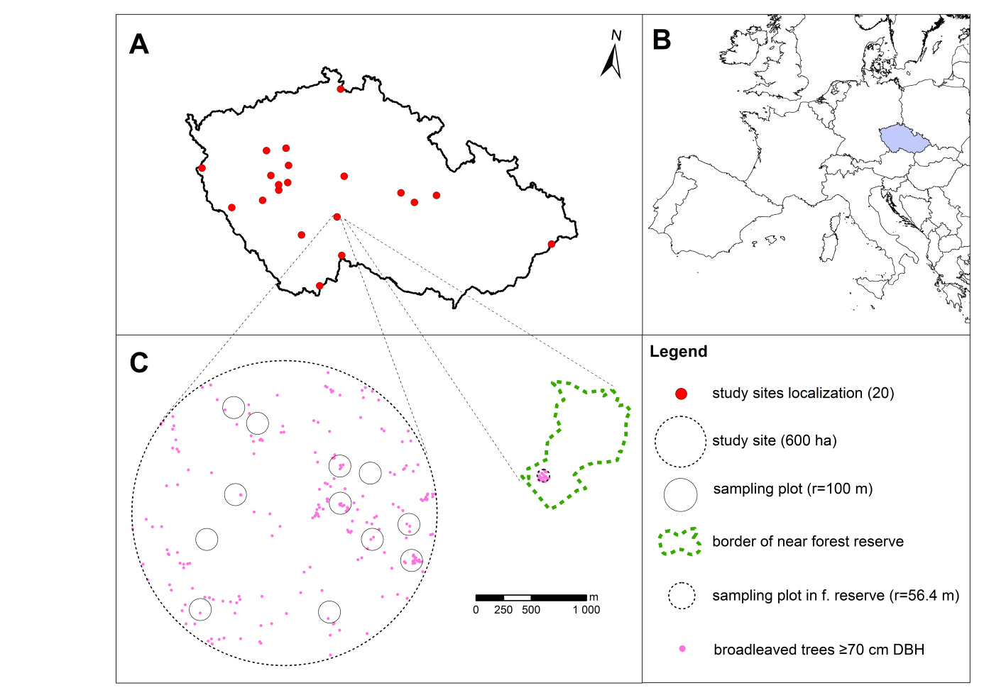
Fig. 1. A) location of all (20) study sites in the Czech Republic; B) location of the Czech Republic in Europe; C) example of study site (600 ha) with localization of sampling plots (r = 100 m), and example of unmanaged forest reserve with 1 ha sampling plot.

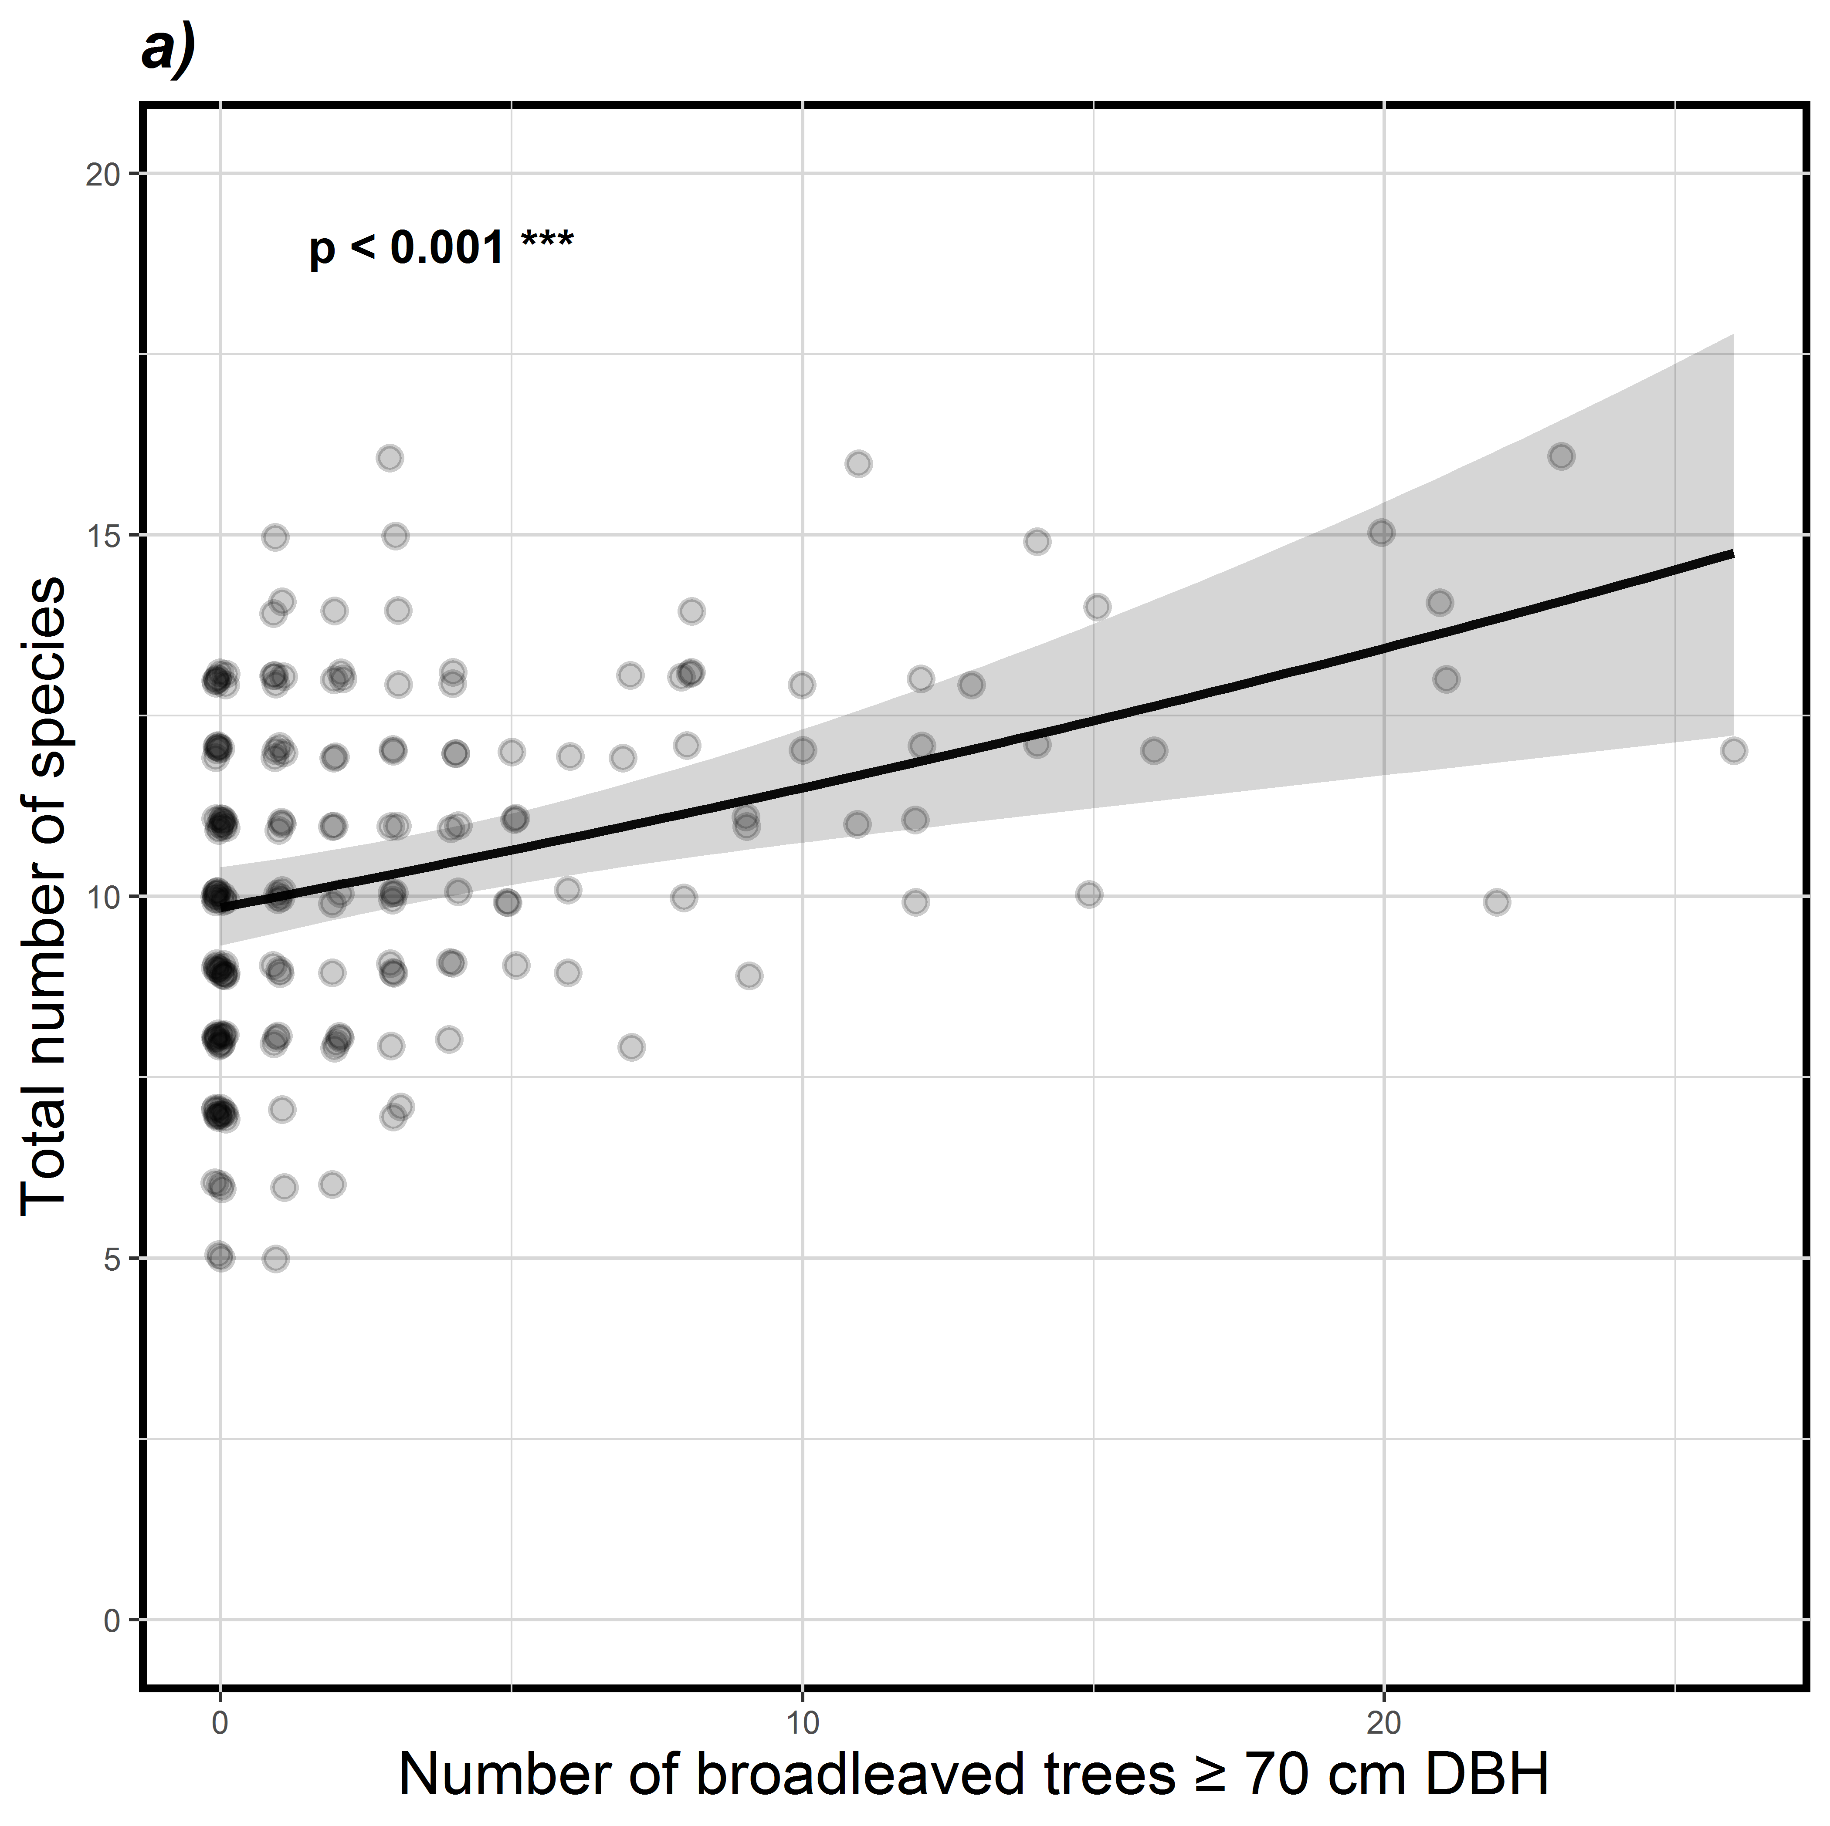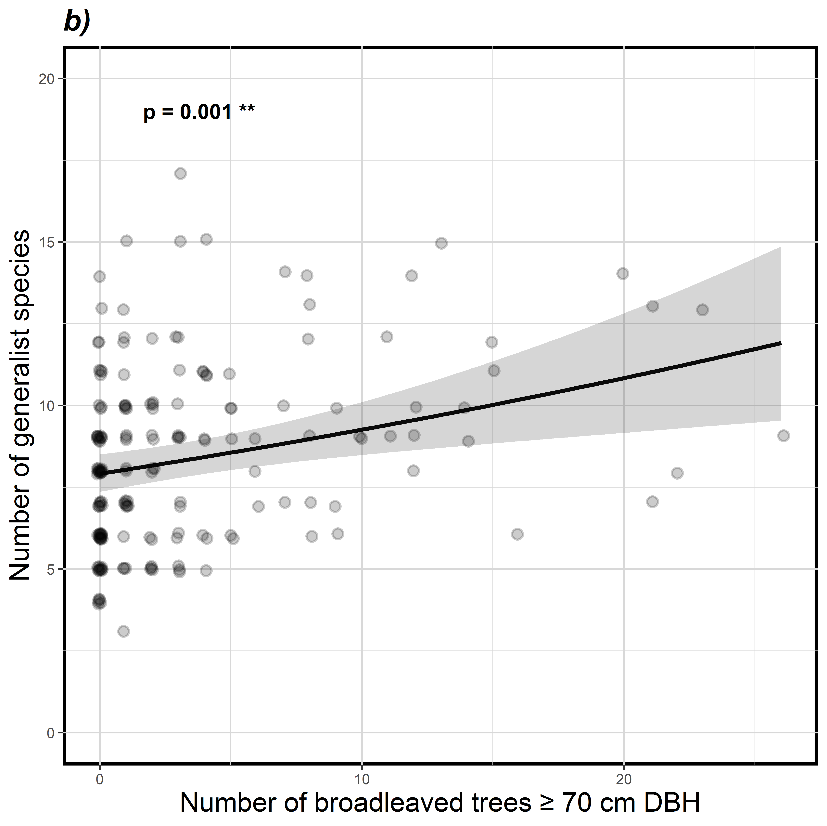
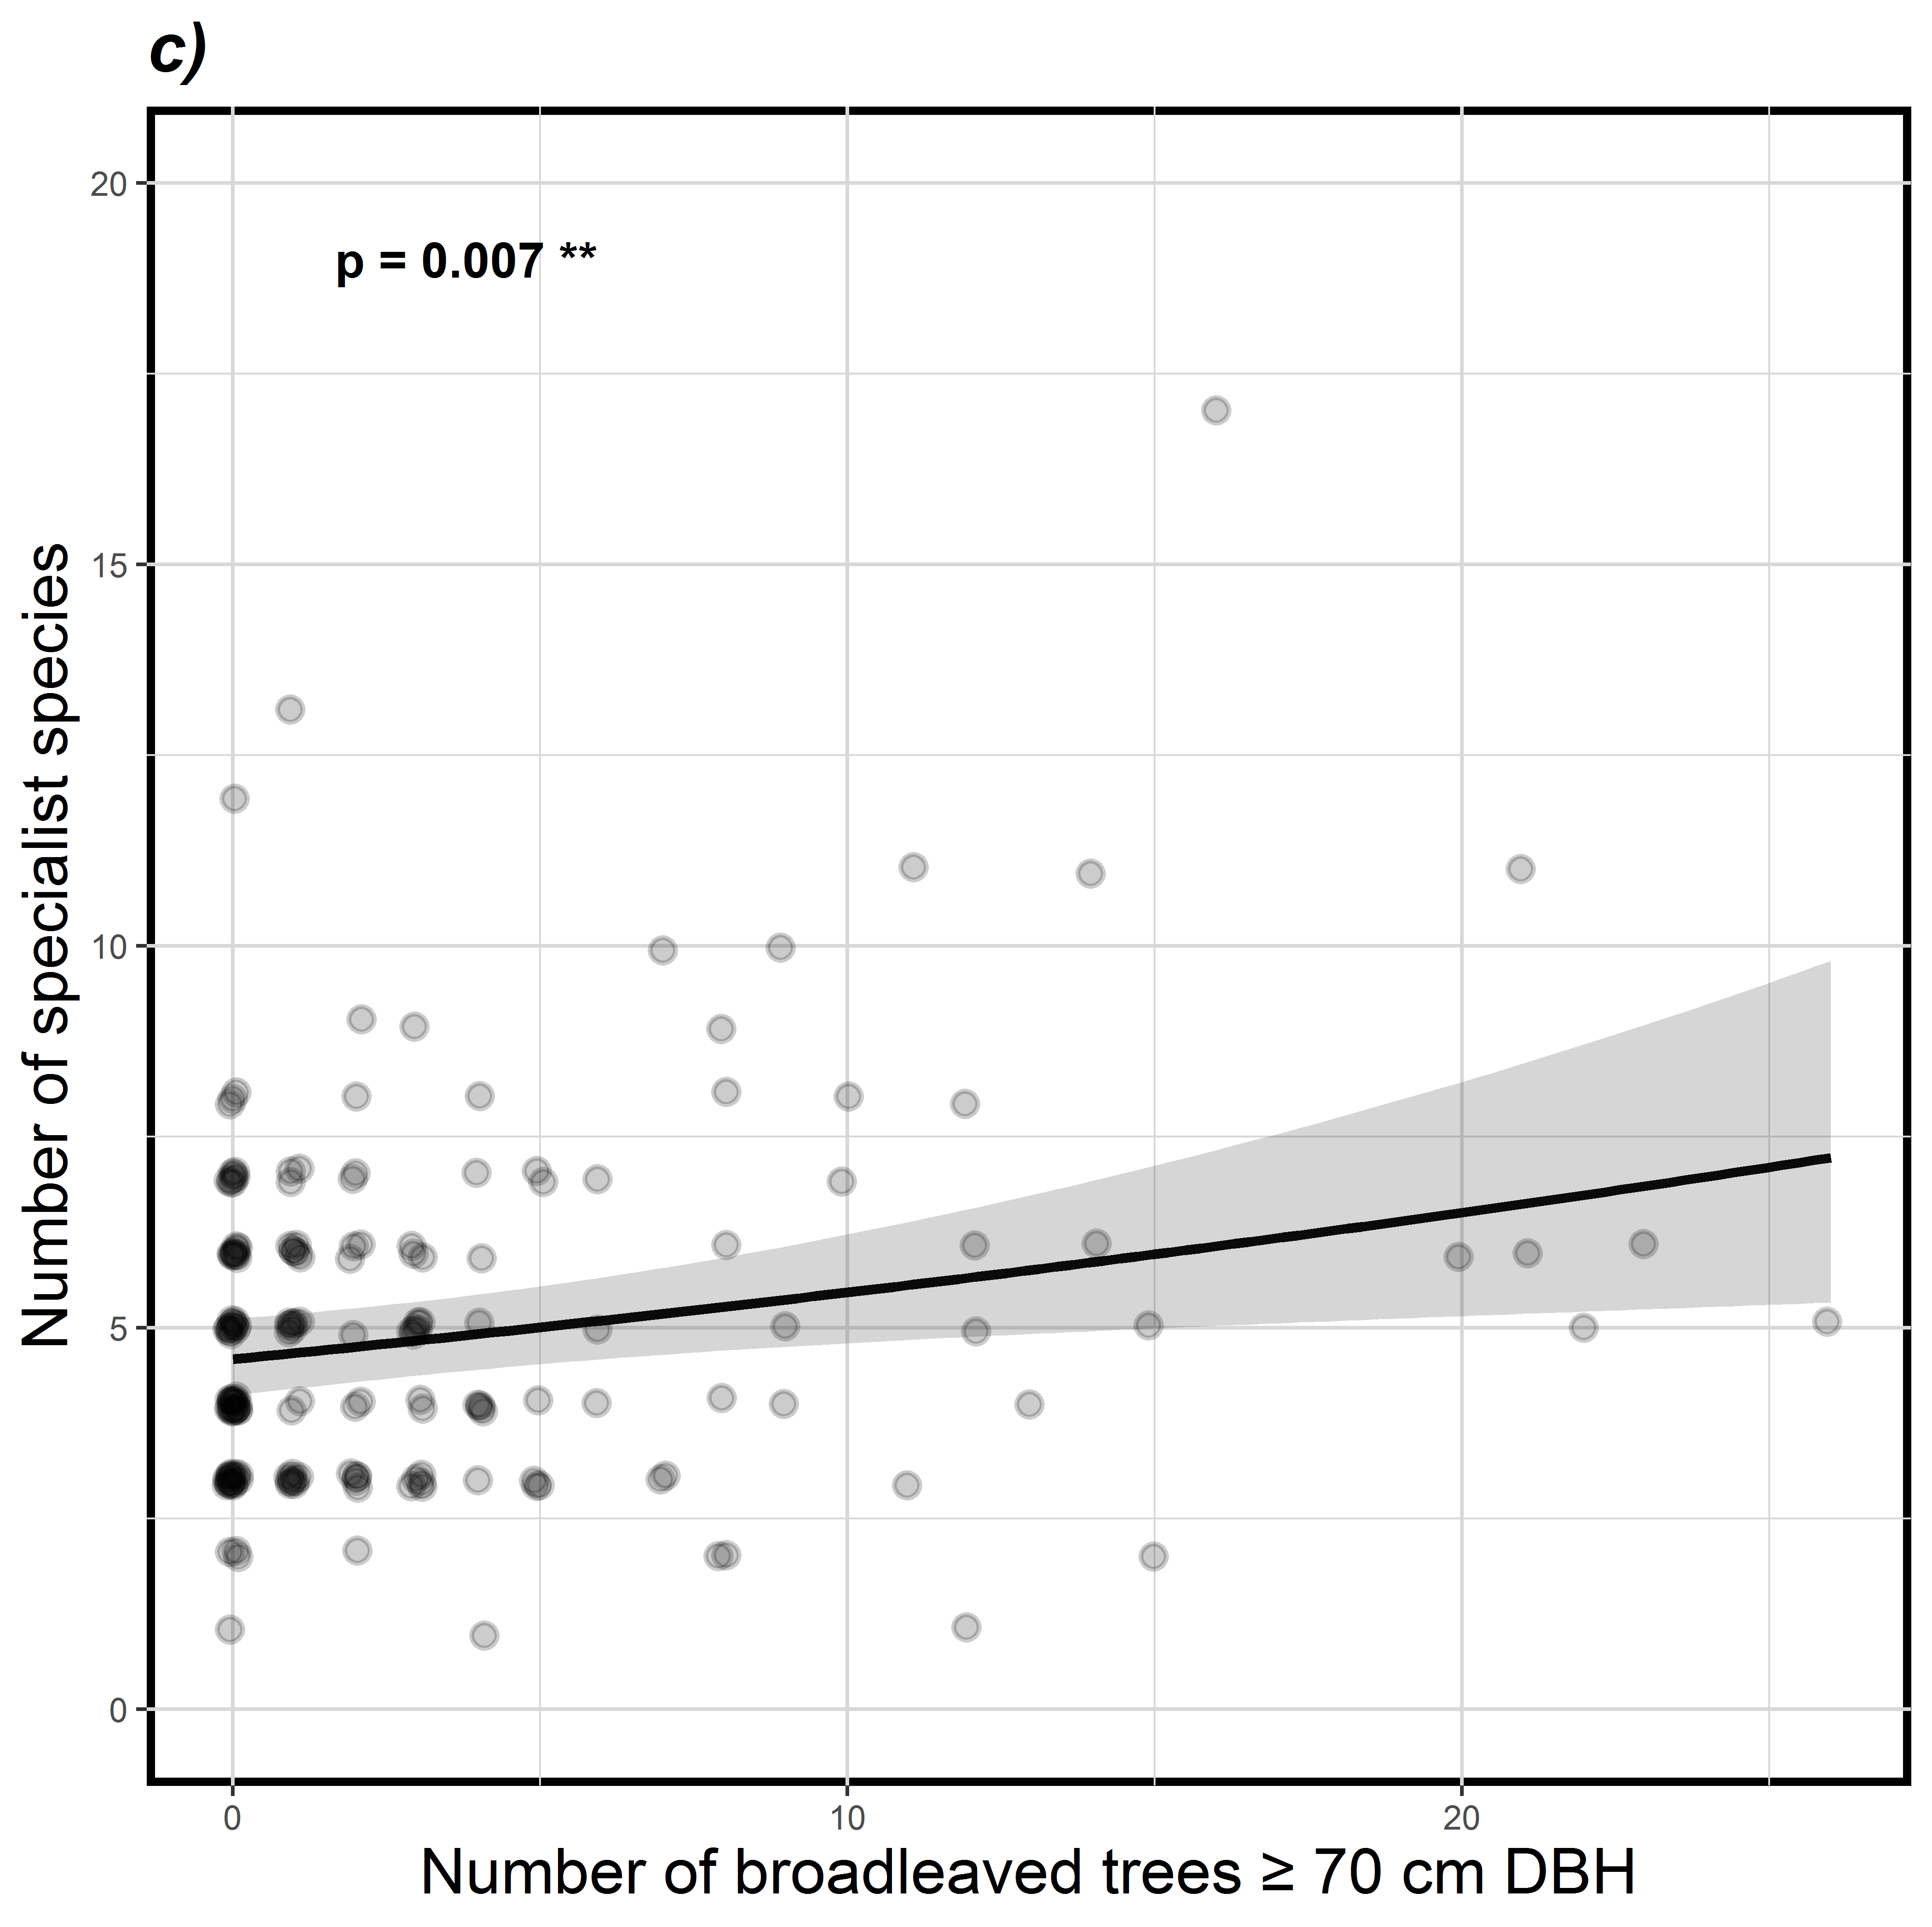
Fig. 2. Relationship between number of live broadleaved trees ≥70 cm DBH within sampling plots (r = 100 m) and total number of bird species (a), generalist bird species (b), or specialist bird species (c) in spruce-dominated production forests (p-value from GLMMs top left). Black line is mean value predicted by GLMM (with the other predictor – Shannon’s tree diversity index – set on its average value) and grey area indicates Wald 95% confident bands conditional on estimates of random effect variance.

Fig. 3. Total number of bird species (a), generalist bird species (b), or specialist bird species (c) between broadleaved trees ≥70 cm DBH density categories (0, 0<>1, 1<>3, or 3<>9 trees per ha) in spruce-dominated production forests and forest reserves (R). The colour scale expresses the mean density of trees in each category (0, 0.6, 1.9, 4.9, and 22.8 broadleaved trees ≥70 cm DBH per ha). Letters indicate differences between each category from post-hoc Tukey’s test on generalized mixed effect models (p-value from GLMMs top left). Values in parentheses show differences in numbers of species between the category and the reference level (r.l.), which is the category without large broadleaved trees. Whiskers indicate Wald 95% confident bands conditional on estimates of random effect variance.

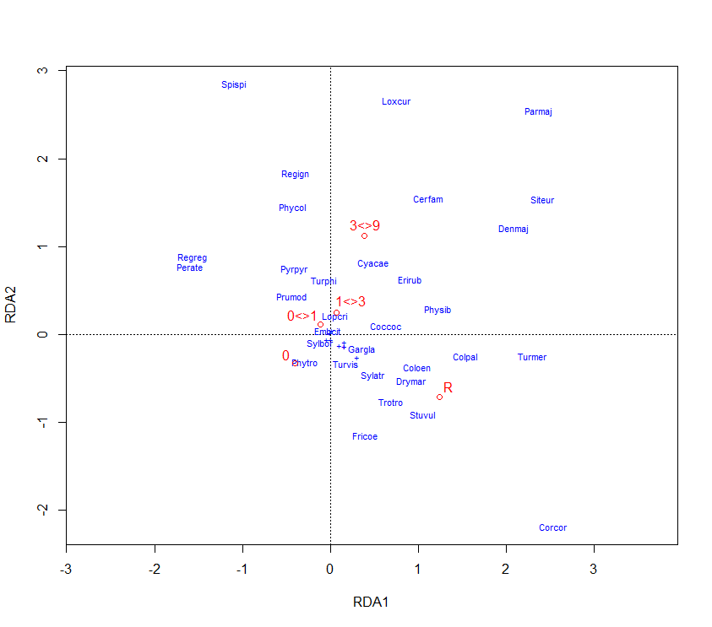
Fig. 4. Plot from redundancy analysis (RDA) showing variability of bird community between broadleaved trees ≥70 cm DBH density categories (0, 0<>1, 1<>3, or 3<>9 trees per ha) in spruce-dominated production forests and forest reserves (R). Abbreviations of species names include first three letters of genus and species scientific names.
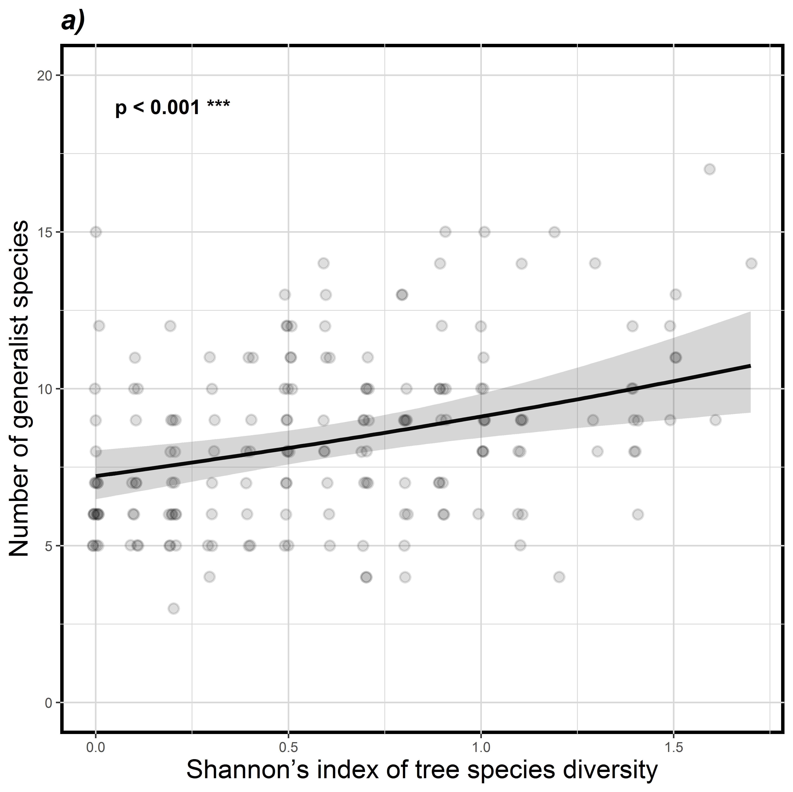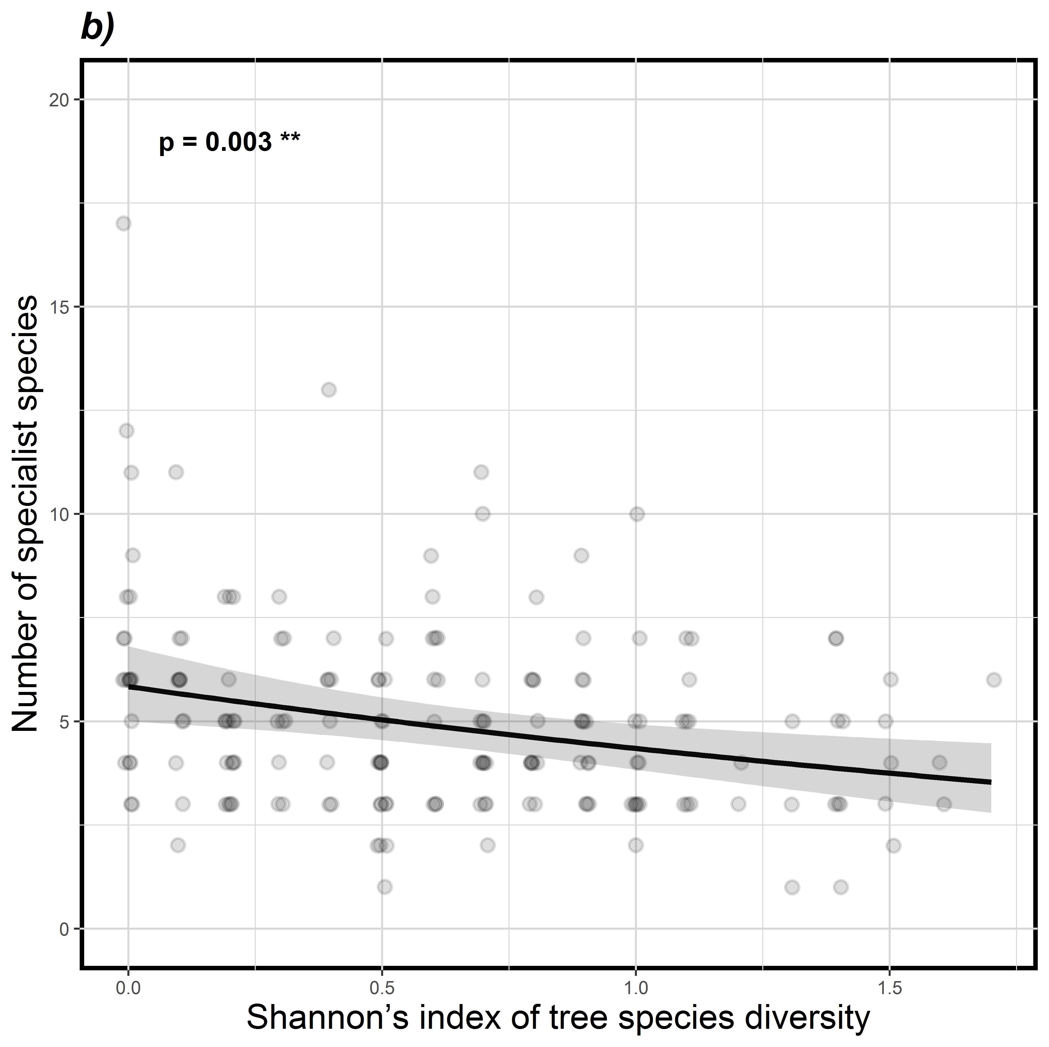
Fig. 5. Relationship between Shannon’s diversity index for tree species and number of generalist bird species (a) and specialist bird species (b) in spruce-dominated production forests (p-value from GLMMs top left). Black line is mean value predicted by GLMM (with the other predictor – number of live broadleaved trees ≥70 cm DBH – set on its average value) and grey area indicates Wald 95% confident bands conditional on estimates of random effect variance

Table 1
Effect of selected stand features in spruce-dominated production forest on total number of bird species, number of generalist bird species, and number of specialist bird species (link scaled)
Bird assemblage | Variable | Est. (SE) | z value | P | Response
Total species richness | NumBroadlLT70DBH | 0.079 (0.021) | 3.721 | <0.001 | +
 | H_Trees | 0.041 (0.023) | 1.793 | 0.073 | +
Generalist | NumBroadlLT70DBH | 0.080 (0.025) | 3.236 | 0.001 | +
 | H_Trees | 0.103 (0.030) | 3.480 | <0.001 | +
Specialist | NumLT70DBH | 0.089 (0.033) | 2.677 | 0.007 | +
 | H_Trees | -0.130 (0.044) | -2.975 | 0.003 | -

Supplementary material:
Supplement 1. All birds recorded in production forest and forest reserves used in the analysis (owls and raptors are excluded). Guild field identifies generalist (G) and specialist (S) species.
 | Species | Abbr. | Guild | Abundance | Density | Dominance | Frequency
 |  |  |  | (individuals) | (1 ha) |  | (% from 180 points)
1 | Fringilla coelebs | Fricoe | G | 402 | 2.0 | 14.5 | 99.5
2 | Periparus ater | Perate | S | 256 | 1.3 | 9.2 | 89.0
3 | Erithacus rubecula | Erirub | G | 249 | 1.2 | 9.0 | 88.0
4 | Regulus ignicapilla | Regign | S | 187 | 0.9 | 6.8 | 81.0
5 | Troglodytes troglodytes | Trotro | G | 153 | 0.8 | 5.5 | 67.0
6 | Certhia familiaris | Cerfam | S | 148 | 0.7 | 5.3 | 69.5
7 | Turdus merula | Turmer | G | 143 | 0.7 | 5.2 | 60.5
8 | Regulus regulus | Regreg | S | 134 | 0.7 | 4.8 | 62.5
9 | Sylvia atricapilla | Sylatr | G | 130 | 0.7 | 4.7 | 56.5
10 | Dendrocopos major | Denmaj | G | 118 | 0.6 | 4.3 | 54.0
11 | Parus major | Parmaj | G | 116 | 0.6 | 4.2 | 45.5
12 | Phylloscopus collybita | Phycol | G | 108 | 0.5 | 3.9 | 49.5
13 | Spinus spinus | Spispi | S | 91 | 0.5 | 3.3 | 23.5
14 | Columba palumbus | Colpal | G | 78 | 0.4 | 2.8 | 33.5
15 | Loxia curvirostra | Loxcur | S | 72 | 0.4 | 2.6 | 18.5
16 | Sitta europaea | Siteur | G | 71 | 0.4 | 2.6 | 32.5
17 | Turdus philomelos | Turphi | G | 47 | 0.2 | 1.7 | 21.5
18 | Prunella modularis | Prumod | G | 37 | 0.2 | 1.3 | 17.0
19 | Pyrrhula pyrrhula | Pyrpyr | S | 30 | 0.2 | 1.1 | 13.0
20 | Phylloscopus sibilatrix | Physib | S | 29 | 0.1 | 1.0 | 13.0
21 | Garrulus glandarius | Gargla | G | 22 | 0.1 | 0.8 | 10.5
22 | Cyanistes caeruleus | Cyacae | G | 22 | 0.1 | 0.8 | 10.0
23 | Coccothraustes coccothraustes | Coccoc | G | 21 | 0.1 | 0.8 | 8.0
24 | Corvus corax | Corcor | G | 18 | 0.1 | 0.7 | 1.0
25 | Turdus viscivorus | Turvis | S | 17 | 0.1 | 0.6 | 8.5
26 | Dryocopus martius | Drymar | S | 9 | 0.0 | 0.3 | 4.5
27 | Anthus trivialis | Anttri | G | 9 | 0.0 | 0.3 | 4.0
28 | Columba oenas | Coloen | S | 8 | 0.0 | 0.3 | 2.5
29 | Phylloscopus trochilus | Phytro | G | 7 | 0.0 | 0.3 | 3.5
30 | Sturnus vulgaris | Stuvul | G | 7 | 0.0 | 0.3 | 1.0
31 | Certhia brachydactyla | Cerbra | S | 4 | 0.0 | 0.1 | 2.0
32 | Sylvia borin | Sylbor | G | 3 | 0.0 | 0.1 | 1.5
33 | Phoenicurus phoenicurus | Phopho | G | 2 | 0.0 | 0.1 | 1.0
34 | Emberiza citrinella | Embcit | G | 2 | 0.0 | 0.1 | 0.5
35 | Ficedula albicollis | Ficalb | S | 2 | 0.0 | 0.1 | 0.5
36 | Ficedula parva | Ficpar | S | 1 | 0.0 | 0.0 | 0.5
37 | Poecile palustris | Poepal | S | 1 | 0.0 | 0.0 | 0.5
38 | Lophophanes cristatus | Lopcri | S | 1 | 0.0 | 0.0 | 0.5
39 | Muscicapa striata | Musstr | G | 1 | 0.0 | 0.0 | 0.5
40 | Nucifraga caryocatactes | Nuccar | S | 1 | 0.0 | 0.0 | 0.5
41 | Dendrocopos leucotos | Denleu | S | 1 | 0.0 | 0.0 | 0.5

